PWDDFL Series Multi-suction head Submerged pump
Overview
1. It can be used in coal pit of coal washery of thermal power plant and discharging high concentration waste water containing coal slag.
2. Municipal, chemical, printing and dyeing, medicine, shipbuilding, foundry, food and other industries can be used to suck thick liquids, turbid liquids, pastes, quicksand and sludge flowing in urban rivers. It can also be used to remove fluid containing mud pebbles in coal mines.
3. Hydraulic mechanized earthwork units with high-pressure pumps and water guns can be used as excavators and transporters in small-scale water conservancy projects such as land leveling, dredging and digging of rivers and ponds, as well as air defense and underground works in cities.
4. Waste water containing high concentration of iron oxide scale in iron oxide pits of smelters.
Product structure of PWDDFL series multi-sucker underwater sewage pump
The pump is a single-stage single-suction vertical centrifugal pump. The fluid flows out along the axis of the pump shaft at 70 degrees. The main components are volute, impeller, pump base, pump shell, support barrel, motor base, etc. The spiral case, pump base, motor base and impeller nut are cast iron with good corrosion resistance and corrosion resistance, and the processing technology is convenient.
The impeller is made of three single-chord curved blades, semi-closed impeller and malleable cast iron, so it has high strength and corrosion resistance. It is easy to process, good throughput and high efficiency. Three single impeller can play a good role in stirring, replacing the traditional structure of stirring head, reducing the shaft power of the pump, saving the cost of motor matching and electricity.
The design of suction head support was removed, and the trafficability of plastic bags and other fibre strips was strengthened.
In order to reduce weight and turning volume, the pump shaft is made of high quality carbon steel cold-drawn round steel.
The pump seat is equipped with four skeleton oil seals and sleeves to prevent shaft wear and prolong the service life of the shaft.

Structural Introduction

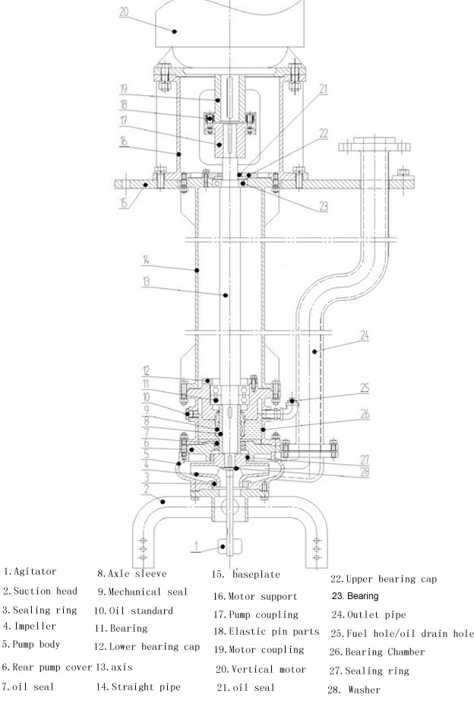
The pump can be used vertically or obliquely, occupying a small area. The volute needs to be buried in the working medium to work. It is easy to start without water diversion. The rotation direction should be clockwise from the rear of the motor. The length of switchboard has various specifications, so that users can choose it according to their use and local conditions.
Instructions for the Use of PWDDFL Series Multi-suction Subliquid Sewage Pumps

1. The power supply of this pump must be three-phase four-wire system. If there is no grounding wire, it must be installed to prevent leakage of electricity. When working, circuit fuses and switches corresponding to the motor should be installed nearby in order to prevent motor from burning when impeller debris is stuck.
2. The pump can operate without installing any basic device, as long as it leans firmly and is fastened by rope when necessary in order to prevent accidents. After starting, the direction of rotation of the motor must be checked. The motor must not be reversed for more than - minutes.
3. When the liquid being sucked contains more weeds, wires, wooden bars, bricks and other debris, it must be removed as far as possible in advance, and wire basket can be added to prevent accidents such as impeller breakdown, blockage and pipeline blockage caused by debris suction pump.
4. Pump body should be given short-term water absorption after absorbing concentrated slurry and other contaminants, so as to flush pump body and pipeline interior.
5. When working in the open air, the motor should be equipped with a protective cover to prevent rain and other immersion into the motor.
6. At the bottom of the river, the suction mud at the bottom of the pond should be suspended on a tripod, and can be put on a buoy or a boat for mobile operation. When carrying out earthwork work, the diameter of the soil broken by the high-pressure water gun shall not be greater than one third of the suction inlet.
7. The speed prescribed by this pump is the highest speed of the pump, and can not be increased arbitrarily. The use of reducing the speed is unlimited, but the effect is significantly reduced.
8. When the pump sucks thick mud, thick liquid or high lift, and conveys coal slurry over a long distance, the load of the pump decreases, but the load can not be increased by changing the structure.
9. Normally running for about 1250 hours, regular maintenance of the pump, removal of the pump seat to check the bearing, and the seal of the pump, cleaning and replacing butter, if necessary, replacing oil seals, bushings and other parts. Notes for maintenance and replacement of parts can be found in installation. (The mechanical seal pump is used to rotate about 3500 hours for regular maintenance).
10. When the scroll case is stopped for a long time, it should be disassembled, the parts wiped and the relative motion joint surface coated with thin oil, stored in a dry place for later use.

Disassembly and Installation of PWDDFL Series Multi-sucker Underwater Sewage Pump
(1) Disassembly
1. Remove motor or fixing plate and outlet pipe.
2. Remove volute and impeller nut, pry back of impeller lightly and remove key impeller.
3. Remove the driven semi-coupling, then remove the key, and then remove the motor base, and separate it from the support barrel.
4. Remove the pump seat and support cylinder bolts to separate them.
5. Remove the sleeve and bearing from the shaft.
(2) Installation
1. Check all parts for defects. All paper cushions should be coated with thin butter on both sides. Two thirds of the butter should be added to the bearing.
2. The skeleton oil seal must be filled with butter, then put into the pump seat, and then installed with bearings.
3. Butter is applied after O-ring is installed in axle sleeve.
4. Install the bearing on the motor base, put paper cushion, oil retaining ring, and fix the shaft and support barrel with screw.
5. Put paper cushion on, install bearing, bush, key, pump seat and impeller, rotate impeller by hand after tightening impeller nut, and turn flexibly.
6. Put paper cushion on pump housing, fix with screw and install filter screen. Then the impeller is pulled by hand, and the rotation is flexible.
7. Pump shaft is equipped with keys and driven couplings, motor shaft is equipped with keys and active couplings, and then motor and motor seat bolts are fixed. After installation, the axial clearance between the active coupling and the driven coupling should be 1-1.5 mm.

Troubleshooting of the PWDDFL Series Multi-suction head Submerged pump

fault | Reason | Solve
Unable to start and run | 1. The feeder is open.  2. The voltage is too low.  3. There is no axial clearance between the two half couplings and they are stuck.  4. The impeller is stuck by debris.  5. The impeller is close to the volute.  6. Dropping of nuts and damage of flat keys make impeller slippery.  7. The flat key of the coupling is damaged. | 1. Check fuses and wiring and replace them.  2. Turn up the voltage or use it when the voltage rises.  3. Adjust the axial clearance between the two half couplings to 1-1.5 mm.  4. Exclude impurities.  5. Re-assembling, separating impeller and volute.  6. Install flat keys and nuts.  7. Change flat keys.
Overload | 1. Improper assembly of each part of the pump makes it difficult to rotate and foreign body is stuck.  2. Concentric bottom change, bearing damage, shaft deformation.  3. Reverse rotation.  4. The head is too low and the flow is too large. | 1. Re-assembly and removal of foreign bodies.  2. Correct parts and replace bearings.  3. Change the direction of the motor.  4. Avoid prolonged use as far as possible.
Insufficient flow | 1. The suction port is blocked and the pit is not deep enough for the pump to suck the medium.  2. The mud pipeline is blocked.  3. Motor speed is lower than rated speed.  4. Impeller damaged.  5. The lift is too high and the transportation is too far.  6. Reverse rotation.  7. Large leakage.  8. The impeller is surrounded by debris.  9. The medium is too thick or the supply is not enough. | 1. Remove the suction obstruction and move the pump so that the volute is completely embedded in the medium water.  2. Check the pipeline and remove the obstruction.  3. Increase the motor speed.  4. Change impeller.  5. Reduce lift and shorten conveying distance.  6. Change the direction of the motor.  7. Check the cause of leakage and replace the parts that cause leakage.  8. Exclude impurities.  9. Dilute the medium and increase the supply.
Noise and vibration | 1. Friction between impeller and volute.  2. The bearing has been damaged or less oil.  3. The pump shaft is not concentric with the motor, and the shaft is bent.  4. The nut is loose.  5. There are impurities in the volute.  6. There are hard substances in the working fluid.  7. There is air infiltration in the suction.  8. The temperature of pumping liquid is too high. | 1. Check the assembly of the pump and adjust it.  2. Replacement of bearings or refueling.  3. Adjust concentricity and correct axis.  4. Tighten the nut.  5. Exclude impurities.  6. Control the size of impurities in the intake pump and encrypt the filter.  7. Deep-buried volute.  8. Reduce the liquid temperature.

