Ⅰ.General
Type DG pump is single-suction, multi-stage, segmental centrifugal pump. It is used for feeding water of low-middle pressure boiler as well as pumping high lift water of factory and city. It is provided for delivering clear water or other liquid which is physically similar to clear water. The temperature of the liquid for type DG85-80 and 200DG43 pump is -20℃～150℃，the temperature of liquid for the others usually is -20℃～105℃. The maximum inlet pressure is not allowed more than 0.59MPa(6kgf/cm²).
Performance range
Capacity Q:6～346m³/h
Head H:102～1056m
Description of pump type
Example 1 40DG₁40×6
40------------Inlet diameter of pump(mm).
DG₁---------Single-suction, multi-stage, boiler feed water pump.
40-----------Single-stage head of pump(m).
6-------------Pump stage number
Such as type 40DG₁40.
Example 2 DG25-50×5
DG----------Single-suction, multi-stage, boiler feed water pump.
25-----------Pump capacity(m³/h).
50-----------Single-stage head of pump(m).
5-------------Pump stage number.
Such as type DG25-50 、DG46-50、DG85-67、DG155-67.
Example 3 DG80-30×4
DG----------Single-suction, multi-stage, boiler feed water pump.
80-----------Inlet diameter of pump(mm).
30-----------Single-stage head of pump(m).
4-------------Pump stage number.
Such as type DG80-30.
Ⅱ.Construction
The constructions of the type DG pumps are described in figure 1.
1. Casing element: The casing element is composed of inlet section, middle section, diffuser vane, outlet section, and end cover, connected by studs. The inlet and outlet of the pump are both vertical.
2. Rotor element: The rotor element mainly consists of shaft, impeller, shaft sleeve, bearing bush and balance disk, the parts that are assembled on the shaft are fixed with key and sleeve nuts.
3. Balance mechanism for axial thrust: This part consist of balance sleeve, balance plate, balance disk and balance water pipe.
4. Bearing element: The bearing element is composed of bearing body and bearing. The rotating or sliding bearing is adopted according to the different type of the pumps in the following table:
Type of pump | bearing |  |  | Methods of  lubricating | Methods  of  cooling
 | Model | Type | Number in a pump
DG25-50 | Short column roll bearing | 2308 | 2 | Lubricating  grease
DG46-50 |  | 2308 | 2 | Lubricating  grease
40DG₁40 |  | 2306 | 2 | Lubricating  grease
DG80-30 |  | 2307 | 2 | Lubricating  grease
DG85-67 | Sliding bearing |  | 2 | Lubricating  oil | Water cooling
DG155-67 |  |  | 2 | Lubricating  oil | Water cooling
DG85-80 |  |  | 2 | Lubricating  oil | Water cooling
DG155-100 |  |  | 2 | Lubricating  oil | Water cooling

5. Stuffing box and sealing elements:
The shaft seal uses packing seal or mechanical seal.
6. The rotation of the pump：The rotation of the pump is in clockwise direction, looking from the end of the motor. The driving end may be moved to another one according to customers’ requirements, meantime, the rotation of the pump is counter clockwise looking from motor to pump.

Sectional Arrangement Fig 1 for Type DG Pump (with Roller Bearing)

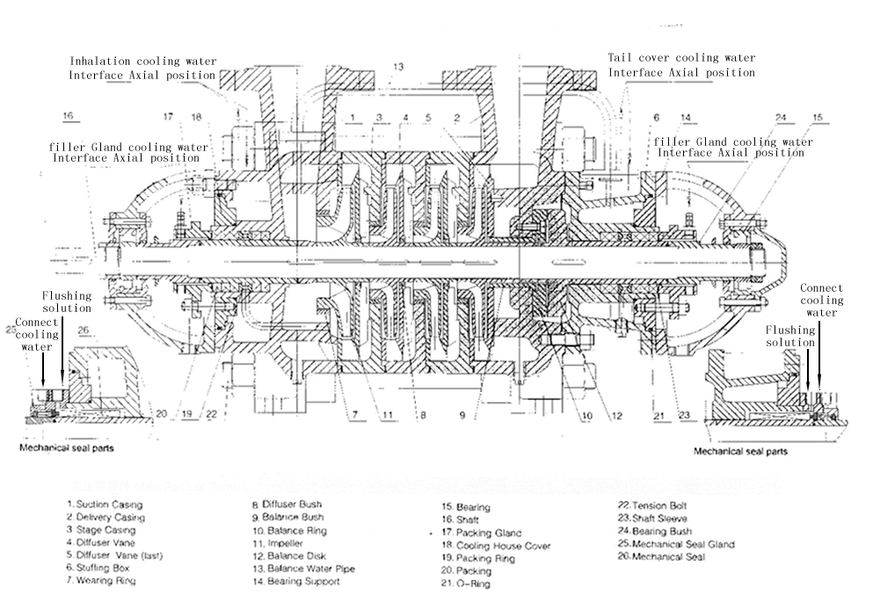
Structural Drawing 2 of DG Type Pump (Thin Oil Lubrication of Rolling Bearing)
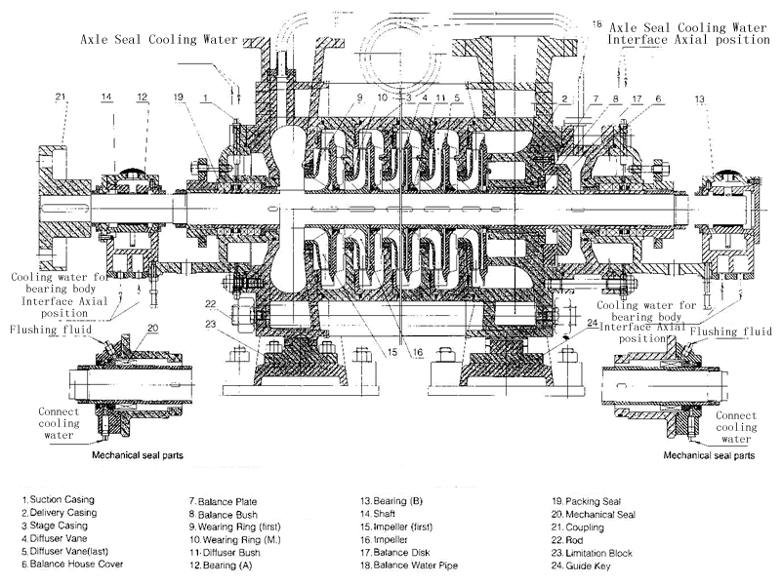
Drawing 3 of DG Pump Structure (Sliding Bearing Thin Oil Lubrication)
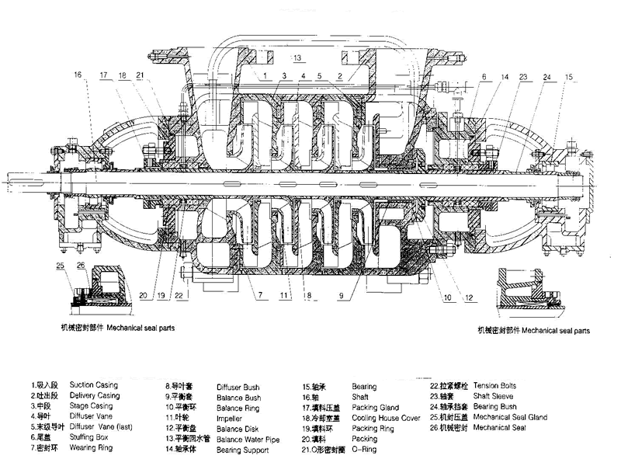
DG pump structure diagram 4 (central support)
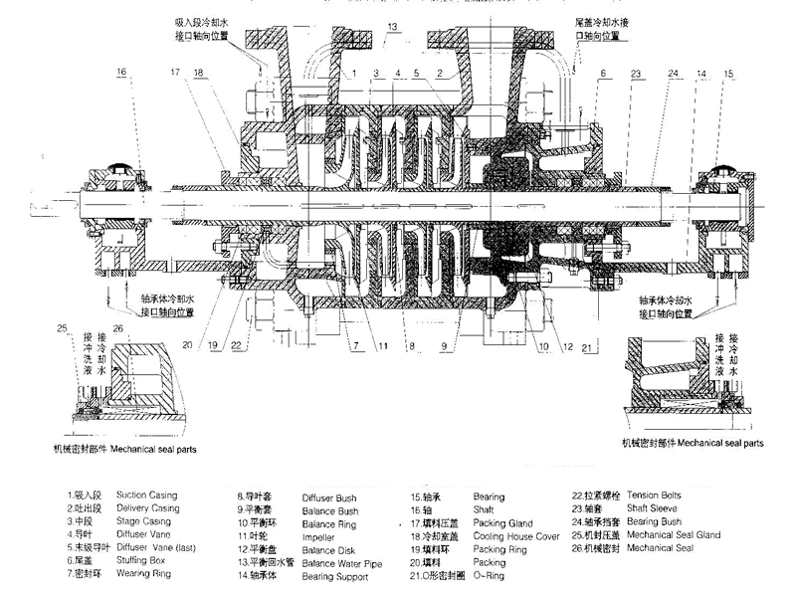
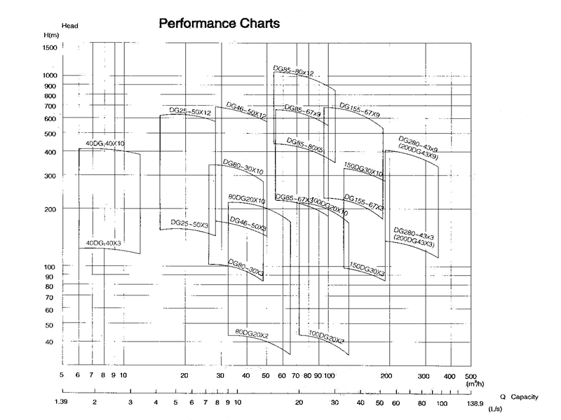

III. Instructions for installation and use of pumps
Assembly of pumps
The assembly quality of this type of pump directly affects the normal operation of the pump, the service life and performance of the pump, and the vibration and noise of the unit. Attention should be paid to the following points in assembly:
A. The concentricity of fixed parts after assembly depends on the manufacturing accuracy and assembly quality of the parts. The processing accuracy and surface roughness of the parts should be well protected. No touching or scratching should be allowed. Molybdenum disulfide used as sealant should be clean and the fastening bolts and bolts should be uniformly stressed.
B. The neutrality of the outlet runner of impeller is guaranteed according to the axial size of each part. The neutrality of the runner directly affects the performance of the pump, so the size of the pump can not be adjusted at will.
C. After the assembly of the pump, before the packing is not installed, the pump rotor is rotated by hand to check whether the rotation of the rotor in the pump shell is flexible and whether the axial momentum meets the required requirements.
D. After the above inspection is qualified, the packing is pressed into the packing chamber at both ends of the pump, and the relative position of the packing ring in the packing chamber is noticed.
Pump disassembly
A. Pump disassembly is carried out in reverse order of assembly. When disassembly, the manufacturing accuracy of the parts on the pump should be strictly protected from damage.
B. When disassembling the piercing rod, the middle sections should be cushioned so as to avoid the loosening and sinking of the stops in the middle sections and the axial compression and bending.
Pump Installation
In addition to meeting the general installation technical conditions, the following points should be paid attention to when this type of pump is installed:
1. When the motor and the pump are assembled, the end axle of the pump coupling should be extended outward, and the axial clearance between the pump and the motor coupling should be guaranteed.
2. The axis line of the pump and the motor should be in the same horizontal straight line.
3. Pumps can only withstand their own internal forces and can not withstand any external forces.
Starting, running and stopping of pumps
Start:
1. Before starting, the rotor should be discharged to check whether the rotor is flexible.
2. Check whether the motor steering is consistent with the pump steering.
3. Close the outlet gate valve, the pressure gauge rotary plug, and use the conveying liquid or vacuum system to remove the air in the suction pipe and pump.
4. Check the tightness of the bolts connecting the pump and the motor and the safety situation around the pump, so that the pump is in the ready state.
5. Start the pump, when the pump is running normally, open the rotary plug of the pressure gauge, slowly open the outlet gate valve of the pump, read and control the given lift of the pump according to the outlet pressure gauge.

Operation:
1. The pump balances the axial force by the balance mechanism in the pump. There is balanced liquid flowing out of the balance device. The balanced liquid is connected from the balance pipe to the suction section. In order to ensure the normal operation of the pump, the balanced pipe must not be blocked.
2. There is no cooling device for the rolling bearings of this type of pump. The temperature rise of the bearing reflects the assembly quality of the pump. Bearing temperature rise shall not be higher than the ambient temperature of 35 C, bearing maximum temperature shall not be higher than 75 C.
3. The rotor of this type of pump has certain axial movement in operation, so the clearance between the end face of motor and pump coupling should be ensured.
4. Pump impeller should be inspected regularly during operation. Wear condition of seal ring, guide vane sleeve, shaft sleeve and balance disk should be replaced in time when wear is too large.
5. Pump in use according to specific circumstances, the detailed operating procedures.
Stop: Close the pressure gauge cock before stopping, and slowly half-close the outlet gate valve. Stop the motor after the outlet gate valve is closed.
Ⅳ.Technical Requirements of Employment
1. The installation of the multistage pump must be strictly leveled to avoid producing the un-normal operation of the rotor.
2. The running of the rotor should be very free and light, and there should be no frictional phenomenon;
3. While working, the pumping machine group should be smooth and steady, and there should not be any vibration, noise and cracks. The max vibration should be less than 0.05 mm
at the bearing;
4. The permissible axial movement of the pump rotor is 2~5 mm. The movement should be free, un-pinned and un-caught in operation;
5. The water flowing must be free and unblocked in the balance water pipe for securing the pressure nearness between the inlet section and the balance water pipe;
6. The temperature of the bearing should not be too high, the permissible temperature of the sliding bearing is≤65℃，but the temperature of the rotating bearing is≤70℃;
7. The cooling chamber of the stuffing box and the bearing should be cooled by the water, of which the temperature is normal and the pressure is 0.5~1.5 kg. force /cm²;
8. The stuffing box should be sealed by the normal temperature water (or pumping cold water) for the water pump.
9. The minimum clearances must secure that the frictions are not produced between impeller and sealing ring, impeller hub and diffuser van sleeve, balance
10. A pressure gauge should be severally located an the inlet and outlet of the pump (a vacuum or vacuum pressure gauge should be setup at the inlet when the pressure is lower than an atm. in it) for inspecting the condition of operation. The reading if the vacuum gauge should not be cover norm on the mark plate or books.
Suction vacuum (m. water column) is the reading of vacuum gauge.
The equation of the suction head (or net positive suction head) is

10(Pa-Pv) Vs²
△h= －Hs＋
r 2g
Pa-----Atmospheric pressure (kg.f/cm²)
Pv-----Vapor pressure of pumping liquid (kg.f/cm²)
Hs-----The suction vacuum of the pump in the inlet.
Vs-----The velocity of the liquid in the inlet of the pump (m/sec)
g------Acceleration of gravity (m/sec²)
r------Specific gravity for Pumping Viscous Medium

V.Possible troubles and their remedies
Troubles | Causes | Remedies
1. No water comes out of the pump | (1)Incorrect direction of the pump rotation. | (1)Change driving direction of the motor.
 | (2)Insufficient liquid poured into the pump before operation (insufficient vacuum produced in employing the vacuum pump.) | (2)Fill the pump with liquid and have the impellers submerged at least, and for the best fill the pump chamber. ( The same applies to sucking up vacuum)
 | (3)Foot valve is not open or blocked. | (3)Check clean or replace foot valve.
 | (4)Suction head is too high, over normal value on the mark plate. | Reduce setting location of the pump.
 | (5)Air leaks in the suction pipe. | (5)Check the flange face of the suction pipe, tighten the joining bolts.
 | (6)Air leaks in the joint of the meter. | (6)Check the joint of the meter, block up the leakage.
 | (7)Air leaks in the pump from the stuffing box. | (7)Check the shaft sleeve and sleeve nut. A washer should be put between the faces of the both ends when air leaks in.
 | (8)Impellers blocked up. | (8)Clean the impellers.
 | (9)Rotating speed too low. | (9)Check the motor, find out the causes, adjust or replace the motor for the pump.
2.Insufficient discharge charge capacity | (1)Water flow passage blocked up. | (1)Check the passage, see whether it is blocked from the inlet to outlet (including the building of the hydraulic engineering) and clean up the passage.
 | (2)Wearing clearance too much between the impellers and sealing rings. | (2)Adjust or replace the impellers and sealing rings for normal clearance.
 | (3)Rotating speed too low. | (3)Check whether the voltage is too low and the motor has been damaged. If necessary, repair the motor or adjust voltage so as to make the rotating speed up to the mark.
3. Power of the pump consumed too much and the current of the motor is over value | (1)Stuffing pressure too tight; | (1)loosen the nut of the stuffing gland;
 | (2)Friction produced between the  rotor and the stator | (2)Check friction part on the rotor and the  stator, especially the part at the small elear-  ance between the impeller and the sealing  ring
 | (3)Discharge capacity of the pump  exceeds the limitation of its emplo-  yment; | (3)Employ the pump at the normal flow quantity
 | (4)Friction produced between the  balance disk and ring; | (4)Check the pulsation of the end face of the balance disk, The tolerance must not exceed the normal value. Change them when they are over worn-out;
 | (1)Cavitation prouduced in the pump | (1)Lower setting position of the pump, simplfy the pipe line and reduce losses in the pipe line;
4.During operation strange noise and vibration happen in the pump | (2)Machine parts loosened or dropped | (2)Stop and repair the pump, tighten the parts;
 | (3)Rotor is unbalanced; | (3)Balanced rotor, cut off the unbalanced parts;
 | (4)Shaft bent; | (4)Straighten the main shaft;
 | (5)Eccentric alignment of the pump shaft and that of the motor; | (5)Adjust the concentricity of the machine group;
 | (6)Weak in base; | (6)Strenghten the base;
 | (1)Poor lubricating oil; | (1)Oil the bearing, check the oil ring so as to make the bearing rotate;
 | (2)Shaft bent; | (2)Straighten the shaft;
 | (3)Bearing damaged; | (3)Change the bearing;
 | (4)Eccentric alignment of the pump shaft and that of the motor | (4)Adjust the concentricity of the machine group;

