Summary
D series (D, DG, DY, DM, DF) pumps are single suction, segmental centrifugal pumps.
Performance range:
Flow: Q: 6-540m3/h
Head: H:33~1056m
Axial force balance disk balance, except 85-67, 155-67, 45-80, 85-80, 150-100 pumps using sliding bearings, thin oil lubrication, the rest are using rolling bearings, grease lubrication.
Pump steering: The special purpose of the pump is clockwise rotation from the prime mover end.
The motor and the base of the pump can be supplied as a complete set (the base can be divided into two kinds of work or itself).

According to different uses, D series can be divided into;
D: It is suitable for transporting clear water without solid particles or liquids similar to clear water in physical and chemical properties. The temperature of the transported medium is 0~80 C. The suction port of the pump is horizontal, and the outlet of the pump is vertical upward.
DM: It is suitable for transporting liquid with a small amount of solid particles and similar physical and chemical properties to clear water. The temperature of the transported medium is 0~80 C. The suction port of the pump is horizontal and the outlet of the pump is vertical upward.
DG: It is suitable for transporting clear water without solid particles or objects with physical and chemical properties similar to clear water. The temperature of the transported medium is - 20 ~150 C. The suction and vomiting outlets of the pump are vertical upward.
DY: It is suitable for transporting petroleum products without solid particles or other liquids similar to water. The temperature of the transported medium is -20 C~+400 C. The suction outlet and vomiting outlet of the pump are vertical upward.
DF: It is suitable for conveying corrosive liquids without solid particles. The temperature of the medium being conveyed is - 20 ~150 C. The inlet and outlet of the pump are vertical upward.
All types of pumps above can be sealed with mechanical seals or soft fillers according to user's requirements. Cast iron, bronze, stainless steel or common carbon steel can be used as materials for overflow components.
Model description:
Case 1: D280-43/84*5
D-Indicates single-suction, multi-suction, segmental centrifugal water pump
280 - Indicates the design point flow rate of the pump (m2/h)
43 - Indicates the design point of the pump, single stage head (m)
84 - Represents the design year of the pump
5 - Represents pump series
Case 2: 150D30 *5
150 - Indicates the diameter of the suction port of the pump (mm)
D-Indicates single-suction, multi-suction, segmental centrifugal water pump
30 - Represents the design point of the pump with a 30-stage head (m)
5 - Represents pump series

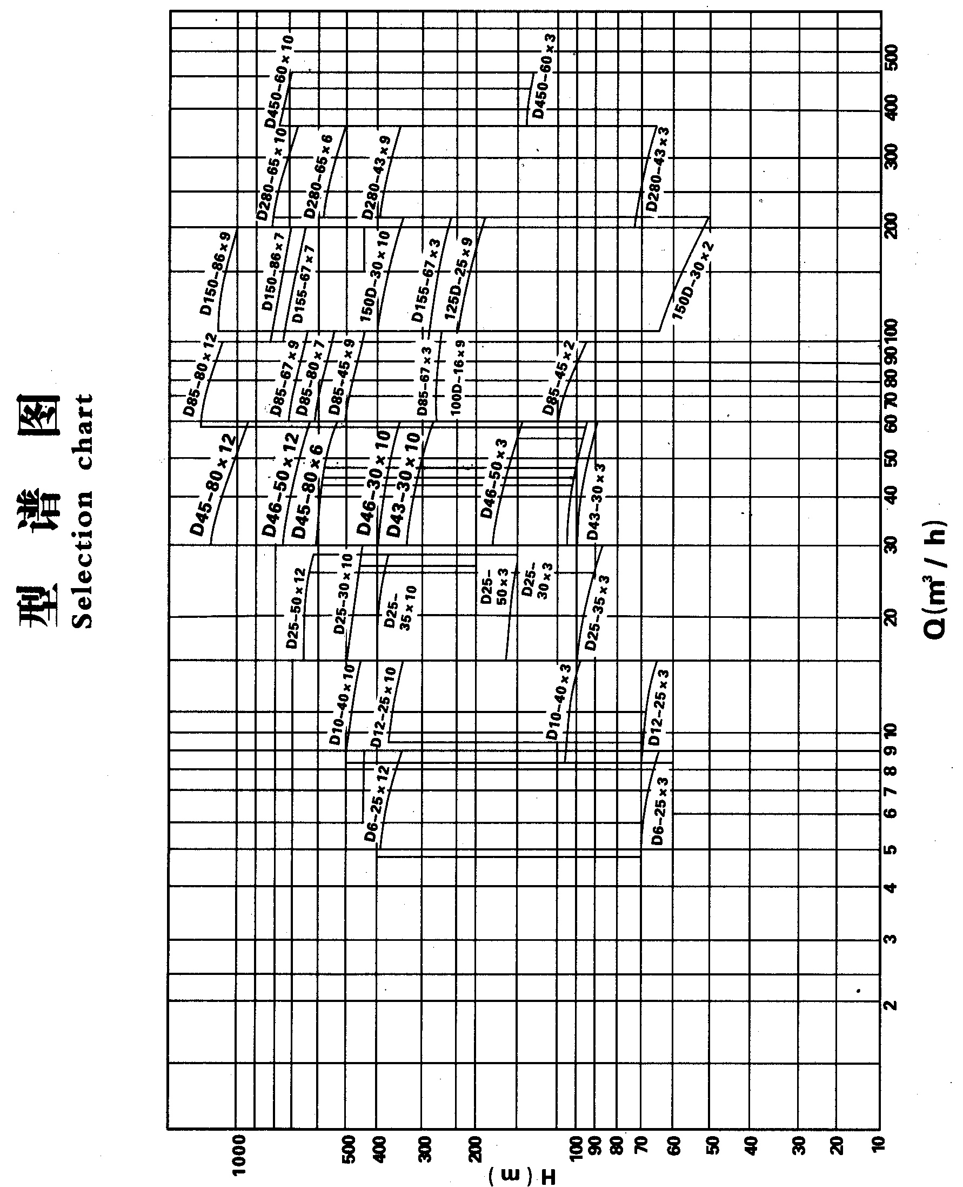
D-type pump (medium and low pressure) structure diagram (water seal water from the outlet of the first stage impeller)

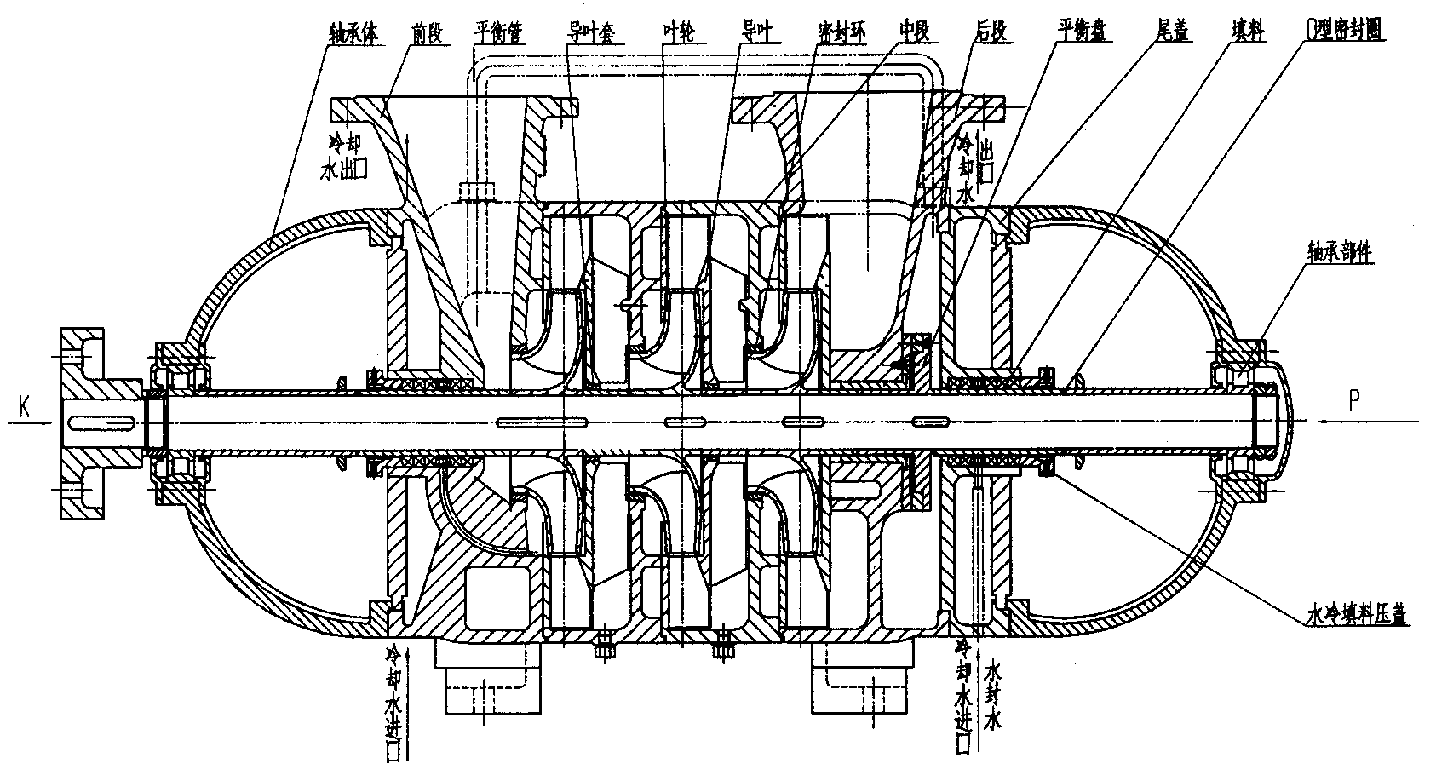

D-type pump (medium and low pressure) structure diagram (water seal water refers to external water)

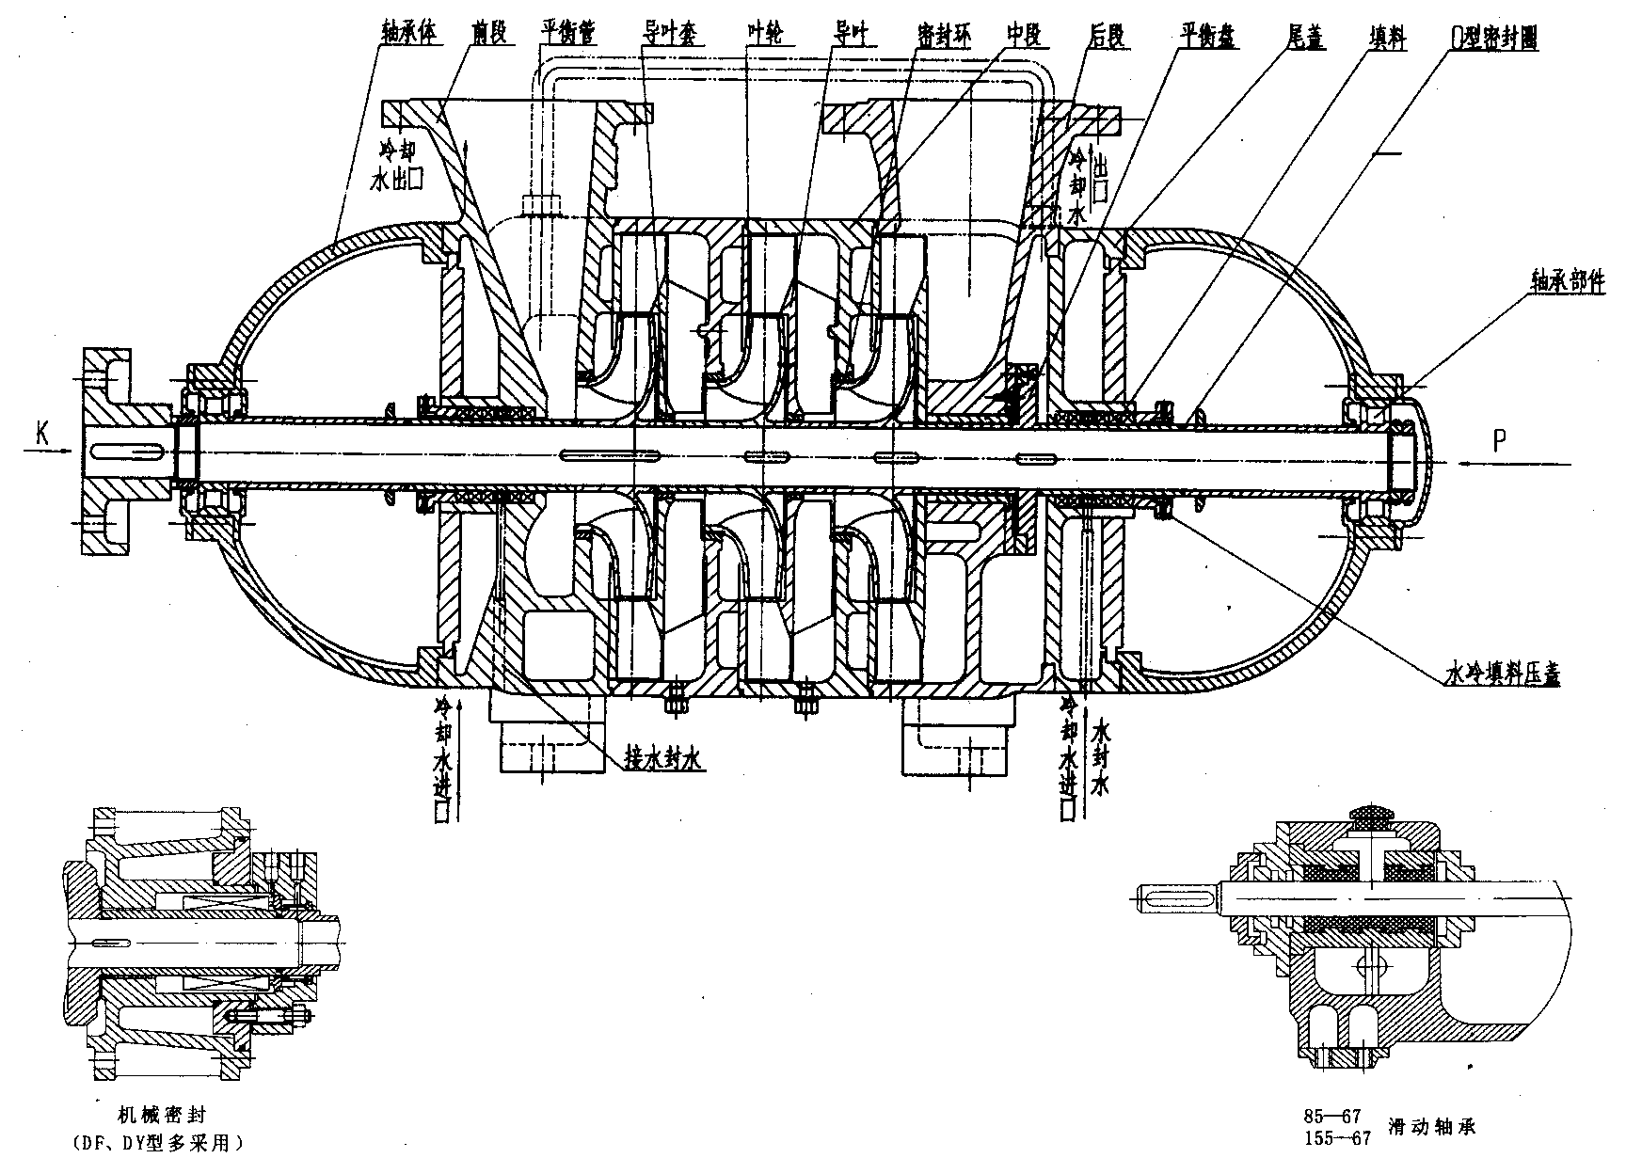

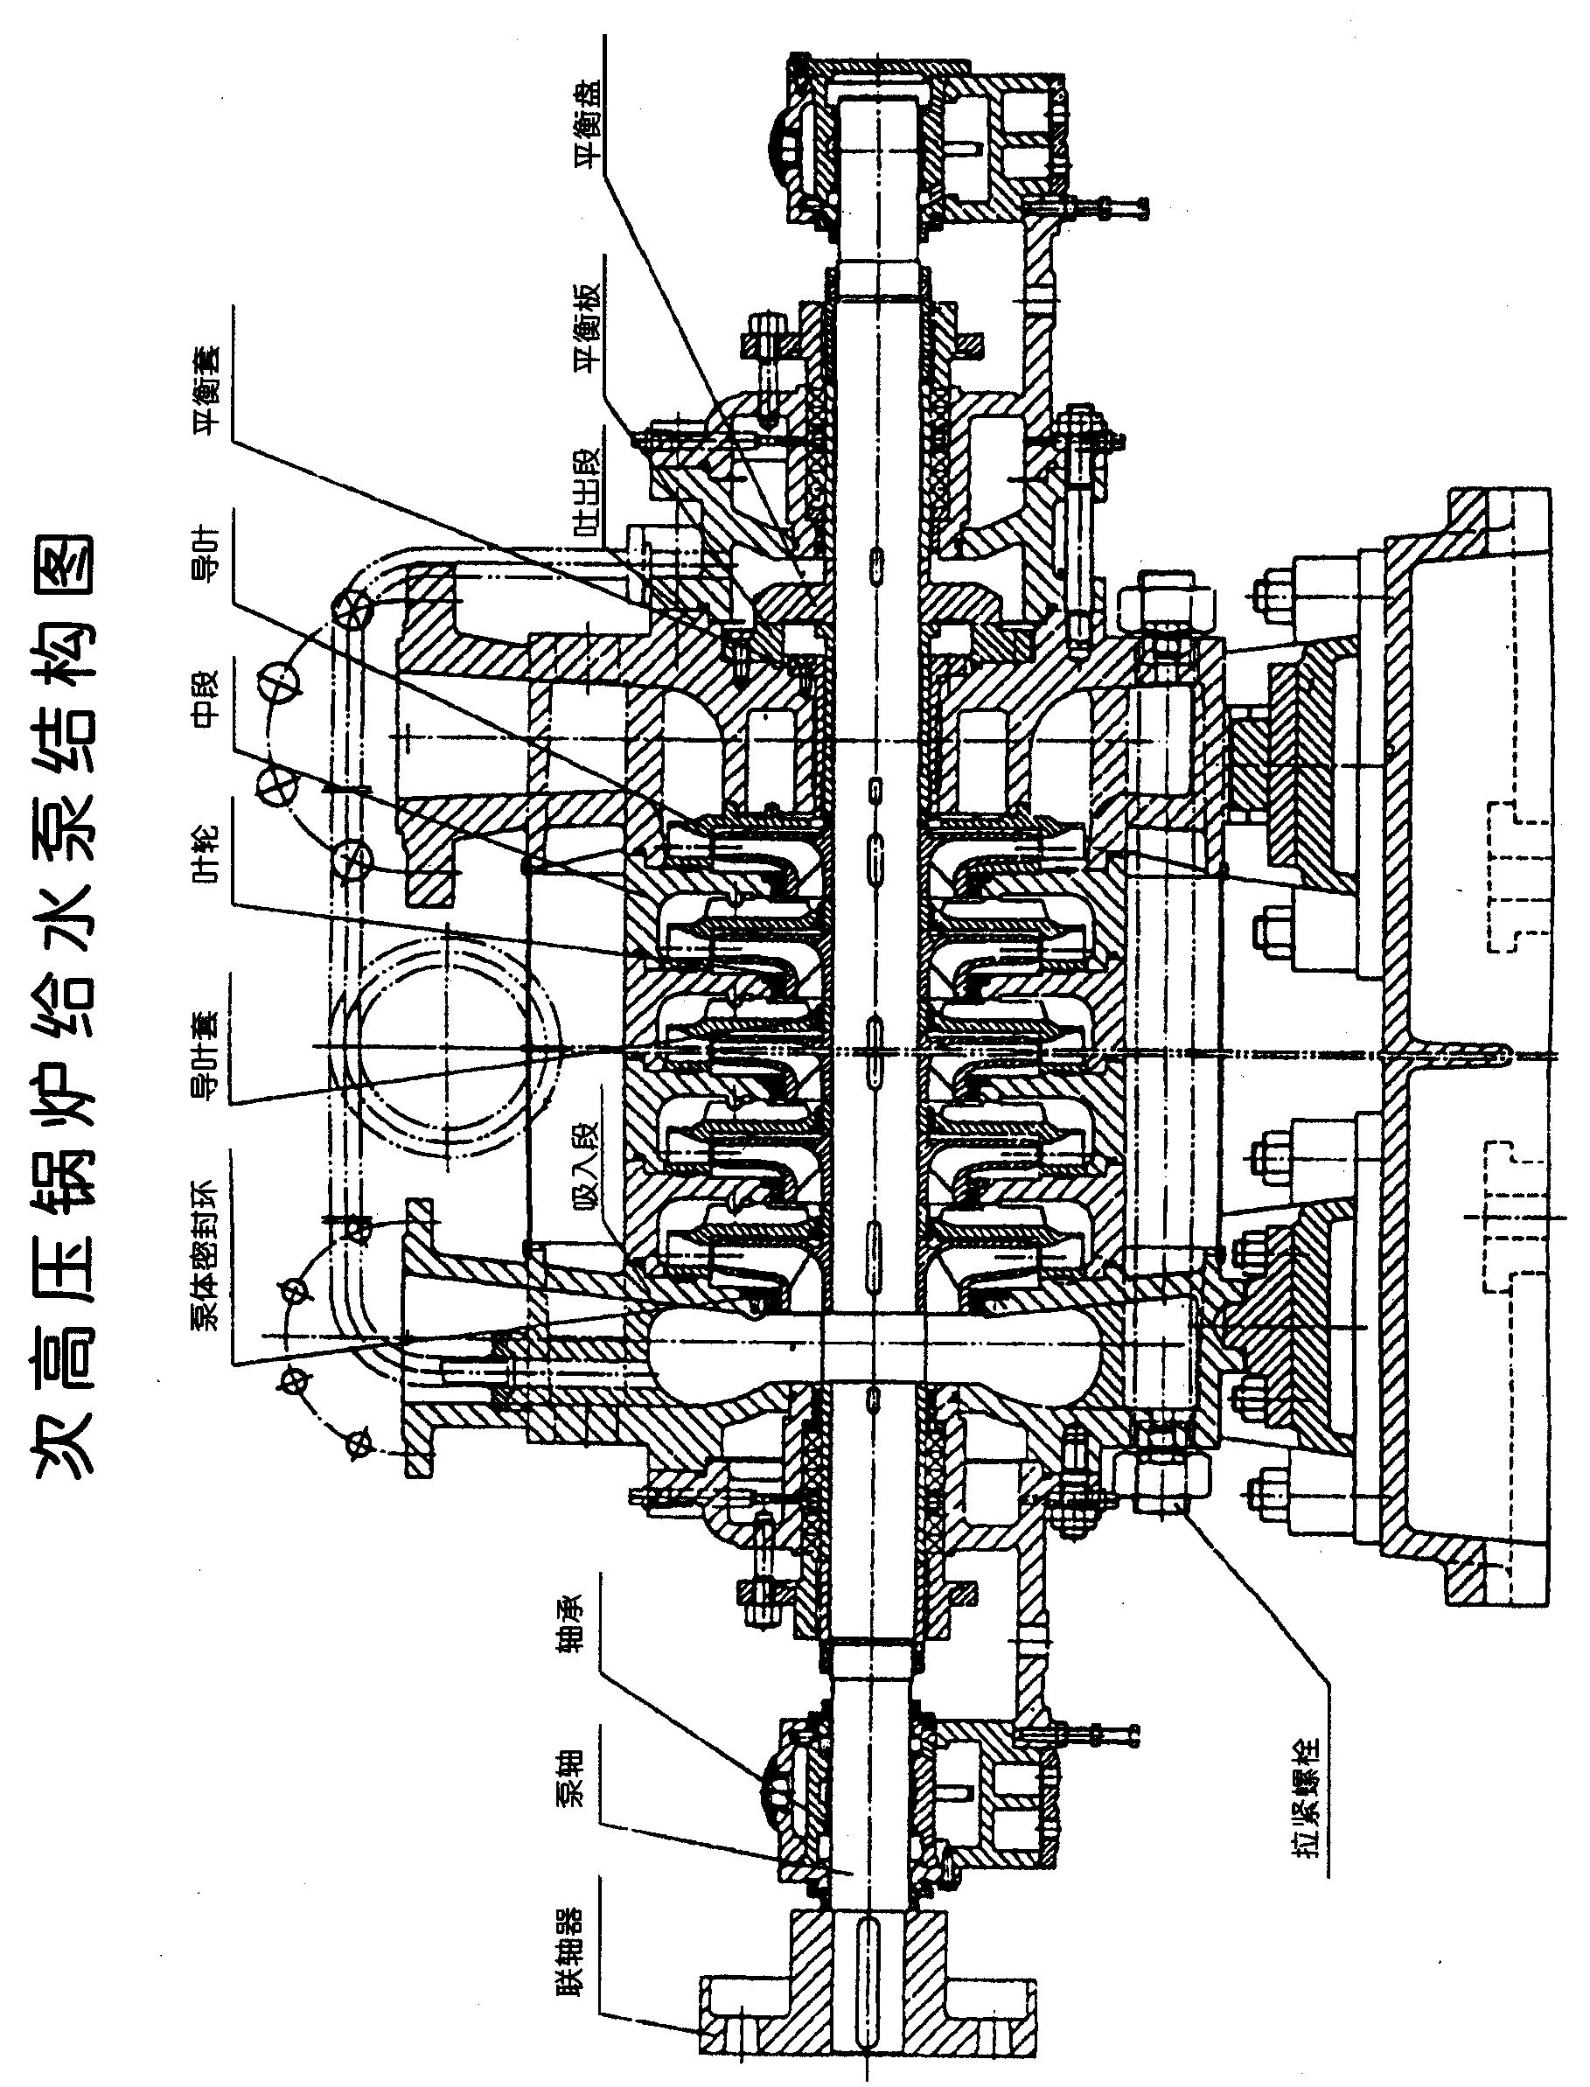

Performance data
Type of pump | Capacity | Head | Rotation  speed | Brake  power | Motor |  | Efficiency | (NPSH)r
 | Q(m³/h⁾ | H(m) | N(r/min) | P(kw) | Power(kw) | Model | η(%) | (m)
D46-50×4 | 28 | 230 | 2980 | 33.1 | 45 | Y YB225M-2 | 53 | 2.5
 | 46 | 200 |  | 39.8 |  |  | 63 | 2.8
 | 50 | 192 |  | 41.3 |  |  | 63.2 | 3.0
D46-50×5 | 28 | 287.5 | 2980 | 41.4 | 75 | Y YB280S-2 | 53 | 2.5
 | 46 | 250 |  | 49.8 |  |  | 63 | 2.8
 | 50 | 240 |  | 51.6 |  |  | 63.2 | 3.0
D46-50×6 | 28 | 345 | 2980 | 49.6 | 75 | Y YB 280S-2 | 53 | 2.5
 | 46 | 300 |  | 59.7 |  |  | 63 | 2.8
 | 50 | 288 |  | 61.9 |  |  | 63.2 | 3.0
D46-50×7 | 28 | 402.5 | 2980 | 57.9 | 90 | Y YB280M-2 | 53 | 2.5
 | 46 | 350 |  | 69.9 |  |  | 63 | 2.8
 | 50 | 336 |  | 72.2 |  |  | 63.2 | 3.0
D46-50×8 | 28 | 460 | 2980 | 66.2 | 90 | Y YB280M-2 | 53 | 2.5
 | 46 | 400 |  | 79.6 |  |  | 63 | 2.8
 | 50 | 384 |  | 82.6 |  |  | 63.2 | 3.0
D46-50×9 | 28 | 517.5 | 2980 | 74.4 | 110 | Y YB315S-2 | 53 | 2.5
 | 46 | 450 |  | 89.6 |  |  | 63 | 2.8
 | 50 | 432 |  | 92.9 |  |  | 63.2 | 3.0
D46-50×10 | 28 | 575 | 2980 | 82.9 | 132 | Y YB315M-2 | 53 | 2.5
 | 46 | 500 |  | 99.5 |  |  | 63 | 2.8
 | 50 | 480 |  | 103.2 |  |  | 63.2 | 3.0
D46-50×11 | 28 | 632.5 | 2980 | 91.0 | 132 | Y YB315M-2 | 53 | 2.5
 | 46 | 550 |  | 109.5 |  |  | 63 | 2.8
 | 50 | 528 |  | 113.5 |  |  | 63.2 | 3.0
D46-50×12 | 28 | 690 | 2980 | 99.3 | 160 | Y YB315L₁-2 | 53 | 2.5
 | 46 | 600 |  | 119.4 |  |  | 63 | 2.8
 | 50 | 576 |  | 123.9 |  |  | 63.2 | 3.0
D85-67×3 | 55 | 222 | 2980 | 61.5 | 90 | Y YB280M-2 | 54 | 3.3
 | 85 | 201 |  | 71.5 |  |  | 65 | 4.0
 | 100 | 183 |  | 76.6 |  |  | 65 | 4.4
D85-67×4 | 55 | 296 | 2980 | 82.1 | 110 | Y YB315S-2 | 54 | 3.3
 | 85 | 268 |  | 95.4 |  |  | 65 | 4.0
 | 100 | 244 |  | 102.2 |  |  | 65 | 4.4

Performance data
Type of pump | Capacity | Head | Rotation  speed | Brake  power | Motor |  | Efficiency | (NPSH)r
 | Q(m³/h⁾ | H(m) | N(r/min) | P(kw) | 功率  Power(kw) | 型号  Model | η(%) | (m)
D85-67×5 | 55 | 370 | 2980 | 102.5 | 160 | Y YB 315L₁-2 | 54 | 3.3
 | 85 | 335 |  | 119.3 |  |  | 65 | 4.0
 | 100 | 305 |  | 127.7 |  |  | 65 | 4.4
D85-67×6 | 55 | 444 | 2980 | 123.1 | 160 | Y YB315L₁-2 | 54 | 3.3
 | 85 | 402 |  | 143.1 |  |  | 65 | 4.0
 | 100 | 365 |  | 152.8 |  |  | 65 | 4.4
D85-67×7 | 55 | 518 | 2980 | 143.6 | 200 | Y YB 315L₂-2 | 54 | 3.3
 | 85 | 469 |  | 166.9 |  |  | 65 | 4.0
 | 100 | 427 |  | 178.6 |  |  | 65 | 4.4
D85-67×8 | 55 | 592 | 2980 | 164.1 | 220 | Y YB355M₁-2 | 54 | 3.0
 | 85 | 536 |  | 190.8 |  |  | 65 | 4.0
 | 100 | 488 |  | 204.3 |  |  | 65 | 4.4
D85-67×9 | 55 | 666 | 2980 | 184.6 | 250 | Y YB355M₂-2 | 54 | 3.0
 | 85 | 603 |  | 214.6 |  |  | 65 | 4.0
 | 100 | 549 |  | 230.0 |  |  | 65 | 4.4
D85-80×7 | 54 | 616 | 2950 | 170.9 | 250 | Y YB355M₁-2  (1P23) | 53 | 4.5
 | 85 | 560 |  | 199.3 |  |  | 65 | 4.4
 | 108 | 490 |  | 218.4 |  |  | 66 | 5.3
D85-80×8 | 54 | 704 | 2950 | 195.3 | 280 | Y YB355M₂-2  (1P23) | 53 | 4.5
 | 85 | 640 |  | 227.8 |  |  | 65 | 4.4
 | 108 | 560 |  | 249.6 |  |  | 66 | 5.3
D85-80×9 | 54 | 792 | 2950 | 219.8 | 315 | Y YB355M₃-2  (1P23) | 53 | 4.5
 | 85 | 720 |  | 256.3 |  |  | 65 | 4.4
 | 108 | 630 |  | 280.2 |  |  | 66 | 5.3
D85-80×10 | 54 | 880 | 2950 | 244.2 | 355 | Y YB355L₁-2  (1P23) | 53 | 4.5
 | 85 | 800 |  | 284.8 |  |  | 65 | 4.4
 | 108 | 700 |  | 311.9 |  |  | 66 | 5.3
D85-80×11 | 54 | 968 | 2950 | 268.6 | 400 | Y YB3556-2  (1P23) | 53 | 4.5
 | 85 | 880 |  | 313.2 |  |  | 65 | 4.4
 | 108 | 770 |  | 343 |  |  | 66 | 5.3
D85-80×12 | 54 | 1056 | 2950 | 293 | 450 | Y YB4001-2  (1P23) | 53 | 4.5
 | 85 | 960 |  | 341.7 |  |  | 65 | 4.4
 | 108 | 840 |  | 347.3 |  |  | 66 | 5.3
Performance data
Type of pump | Capacity | Head | Rotation  speed | Brake  power | Motor |  | Efficiency | (NPSH)r
 | Q(m³/h⁾ | H(m) | N(r/min) | P(kw) | Power(kw) | Model | η(%) | (m)
100D-16×3 | 37.6 | 59.4 | 2980 | 9.21 | 15 | Y YB160M₂-2 | 66 | 3.7
 | 54.0 | 51 |  | 10.27 |  |  | 73 | 3.9
 | 72.0 | 33.6 |  | 9.9 |  |  | 66 | 4.3
100D-16×4 | 37.6 | 79.2 | 2980 | 12.28 | 15 | Y YB160M₂-2 | 66 | 3.7
 | 54.0 | 68 |  | 13.68 |  |  | 73 | 3.9
 | 72.0 | 44.8 |  | 13.32 |  |  | 66 | 4.3
100D-16×5 | 37.6 | 99 | 2980 | 15.35 | 22 | Y YB180M-2 | 66 | 3.7
 | 54.0 | 85 |  | 17.10 |  |  | 73 | 3.9
 | 72.0 | 56 |  | 16.65 |  |  | 66 | 4.3
100D-16×6 | 37.6 | 118.8 | 2980 | 18.64 | 22 | Y YB180M-2 | 66 | 3.7
 | 54.0 | 102 |  | 20.25 |  |  | 73 | 3.9
 | 72.0 | 67.2 |  | 19.98 |  |  | 66 | 4.3
100D-16×7 | 37.6 | 138.6 | 2980 | 21.49 | 30 | Y YB200L₁-2 | 66 | 3.7
 | 54.0 | 119 |  | 23.94 |  |  | 73 | 3.9
 | 72.0 | 78.4 |  | 23.31 |  |  | 66 | 4.3
100D-16×8 | 37.6 | 158.4 | 2980 | 24.56 | 30 | Y YB200L₁-2 | 66 | 3.7
 | 54.0 | 136 |  | 27.63 |  |  | 73 | 3.9
 | 72.0 | 89.6 |  | 26.64 |  |  | 66 | 4.3
100D-16×9 | 37.6 | 178.2 | 2980 | 27.63 | 37 | Y YB200L₂-2 | 66 | 3.7
 | 54.0 | 153 |  | 30.78 |  |  | 73 | 3.9
 | 72.0 | 100.8 |  | 29.97 |  |  | 66 | 4.3
125D-16×3 | 72 | 76.8 | 2980 | 21.3 | 30 | Y YB200L₁-2 | 70.5 | 3.2
 | 101 | 64.5 |  | 22.8 |  |  | 77.5 | 3.9
 | 119 | 52.5 |  | 22.95 |  |  | 74.5 | 4.5
125D-16×4 | 72 | 102.4 | 2980 | 28.4 | 37 | Y YB 200L₂-2 | 70.5 | 3.2
 | 101 | 86.0 |  | 30.4 |  |  | 77.5 | 3.9
 | 79 | 70.0 |  | 30.6 |  |  | 74.5 | 4.5
125D-16×5 | 72 | 128.0 | 2980 | 35.5 | 45 | Y YB225M-2 | 70.5 | 3.2
 | 101 | 107.5 |  | 38.0 |  |  | 77.5 | 3.9
 | 119 | 87.5 |  | 38.3 |  |  | 74.5 | 4.5
125D-16×6 | 72 | 153.6 | 2980 | 42.6 | 55 | Y YB250M-2 | 70.5 | 3.2
 | 101 | 129.0 |  | 45.6 |  |  | 77.5 | 3.9
 | 119 | 105.0 |  | 46 |  |  | 74.5 | 4.5
Performance data
Type of pump | Capacity | Head | Rotation  speed | Brake  power | Motor |  | Efficiency | (NPSH)r
 | Q(m³/h⁾ | H(m) | N(r/min) | P(kw) | Power(kw) | Model | η(%) | (m)
125D-16×7 | 72 | 179.2 | 2980 | 49.8 | 75 | Y YB280S-2 | 70.5 | 3.2
 | 101 | 150.5 |  | 53.2 |  |  | 77.5 | 3.9
 | 119 | 122.5 |  | 53.6 |  |  | 74.5 | 4.5
125D-16×8 | 72 | 204.8 | 2980 | 56.8 | 75 | Y YB280S-2 | 70.5 | 3.2
 | 101 | 172.0 |  | 61.8 |  |  | 77.5 | 3.9
 | 119 | 140.0 |  | 61.2 |  |  | 74.5 | 4.5
125D-16×9 | 72 | 230.4 | 2980 | 63.9 | 90 | Y YB280M-2 | 70.5 | 3.2
 | 101 | 193.5 |  | 98.4 |  |  | 77.5 | 3.9
 | 119 | 157.5 |  | 68.9 |  |  | 74.5 | 4.5
150D-30×3  (D155-30/80×4) | 119 | 98.1 | 1480 | 43.05 | 75 | Y YB280S-4 | 74 | 2.8
 | 155 | 92.1 |  | 50.5 |  |  | 77 | 3.5
 | 190 | 84.0 |  | 58.06 |  |  | 75 | 4.7
150D-30×4  (D155-30/80×4) | 119 | 130.8 | 1480 | 57.4 | 90 | Y YB280M-4 | 74 | 2.8
 | 155 | 122.8 |  | 67.3 |  |  | 77 | 3.5
 | 190 | 112.0 |  | 77.3 |  |  | 75 | 4.7
150D-30×5  (D155-30/80×4) | 119 | 163.5 | 1480 | 71.6 | 110 | Y YB 315S-4 | 74 | 2.8
 | 155 | 152.5 |  | 83.6 |  |  | 77 | 3.5
 | 190 | 140.0 |  | 96.6 |  |  | 75 | 4.7
150D-30×6  (D155-30/80×4) | 119 | 196.2 | 1480 | 85.9 | 132 | Y YB315M₁-4 | 74 | 2.8
 | 155 | 184.2 |  | 101 |  |  | 77 | 3.5
 | 190 | 168.0 |  | 116 |  |  | 75 | 4.7
150D-30×7  (D155-30/80×4) | 119 | 228.9 | 1480 | 100.4 | 160 | Y YB315M₂-4 | 74 | 2.8
 | 155 | 214.9 |  | 118 |  |  | 77 | 3.5
 | 190 | 196.0 |  | 135.5 |  |  | 75 | 4.7
150D-30×8  (D155-30/80×4) | 119 | 261.6 | 1480 | 114.6 | 200 | Y YB315L₂-2 | 74 | 2.8
 | 155 | 245.6 |  | 134.7 |  |  | 77 | 3.5
 | 190 | 224.0 |  | 154.6 |  |  | 75 | 4.7
150D-30×9  (D155-30/80×4) | 119 | 294.3 | 1480 | 128.9 | 200 | Y YB315L₂-4 | 74 | 2.8
 | 155 | 276.3 |  | 151.5 |  |  | 77 | 3.5
 | 190 | 252.0 |  | 173.9 |  |  | 75 | 4.7
150D-30×10  (D155-30/80×4) | 119 | 327 | 1480 | 143.2 | 220 | Y YB355M₁-4 | 74 | 2.8
 | 155 | 307 |  | 158.3 |  |  | 77 | 3.5
 | 190 | 280 |  | 193.2 |  |  | 75 | 4.7
Performance data
Type of pump | Capacity | Head | Rotation  Speed  speed | Brake  power | Motor |  | Efficiency | (NPSH)r
 | Q(m³/h) | H(m) | N(r/min) | P(kw) | Power(kw) | Model | η(%) | (m)
DG150-100×6 | 120 | 630 | 2950 | 307 | 450 | Y YB4001-2  (1P23) | 67 | 3.4
 | 150 | 591 |  | 345 |  |  | 70 | 4.8
 | 180 | 540 |  | 368 |  |  | 72 | 5.5
DG150-100×7 | 120 | 735 |  | 359 | 500 | Y YB4002-2  (1P23) | 67 | 3.4
 | 150 | 698.5 |  | 403 |  |  | 70 | 4.8
 | 180 | 630 |  | 429 |  |  | 72 | 5.5
DG150-100×8 | 120 | 840 |  | 410 | 630 | Y YB4004-2  (1P23) | 67 | 3.4
 | 150 | 788 |  | 460 |  |  | 70 | 4.8
 | 180 | 720 |  | 491 |  |  | 72 | 5.5
DG150-100×9 | 120 | 945 |  | 461 | 630 | Y YB4004-2  (1P23) | 67 | 3.4
 | 150 | 886.5 |  | 518 |  |  | 70 | 4.8
 | 180 | 810 |  | 552 |  |  | 72 | 5.5
DG150-100×10 | 120 | 1050 |  | 512 | 800 | Y YB4502-2  (1P23) | 67 | 3.4
 | 150 | 985 |  | 575 |  |  | 70 | 4.8
 | 180 | 900 |  | 613 |  |  | 72 | 5.5
D  DG155-67×3  DF | 95 | 228 | 2980 | 93.6 | 132 | Y YB315M-2 | 63 | 2.6
 | 155 | 201 |  | 114.7 |  |  | 74 | 4.5
 | 185 | 177 |  | 122.1 |  |  | 73 | 5.7
D  DG155-67×4  DF | 95 | 304 | 2980 | 124.8 | 185 | Y YB315M₁-2  (IP23) | 63 | 2.6
 | 155 | 268 |  | 152.9 |  |  | 74 | 4.5
 | 185 | 236 |  | 162.8 |  |  | 73 | 5.7
D  DG155-67×5  DF | 95 | 380 | 2980 | 156 | 220 | Y YB355M₁-2 | 63 | 2.6
 | 155 | 335 |  | 191.1 |  |  | 74 | 4.5
 | 185 | 295 |  | 203.6 |  |  | 73 | 5.7
D  DG155-67×6  DF | 95 | 456 | 2980 | 187.2 | 280 | Y YB355L₁-2 | 63 | 2.6
 | 155 | 402 |  | 229.3 |  |  | 74 | 4.5
 | 185 | 354 |  | 244.3 |  |  | 73 | 5.7
D  DG155-67×7  DF | 95 | 532 | 2980 | 218.4 | 315 | Y YB355L₂-2 | 63 | 2.6
 | 155 | 469 |  | 267.6 |  |  | 74 | 4.5
 | 185 | 413 |  | 285 |  |  | 73 | 5.7
D  DG155-67×8  DF | 95 | 608 | 2980 | 249.6 | 355 | Y YB355L₁-2  (1P23) | 63 | 2.6
 | 155 | 536 |  | 305.8 |  |  | 74 | 4.5
 | 185 | 472 |  | 325.7 |  |  | 73 | 5.7
D  DG155-67×9  DF | 95 | 684 | 2980 | 280.8 | 400 | Y YB3556-2  (6KV) | 63 | 2.6
 | 155 | 603 |  | 344 |  |  | 74 | 4.5
 | 185 | 531 |  | 366.4 |  |  | 73 | 5.7
DG280-43/84×9  (200D-43×3) | 190 | 135.9 | 1480 | 96.3 | 160 | Y YB315L₁-4 | 73 | 3.0
 | 288 | 122.4 |  | 120 |  |  | 80 | 4.7
 | 346 | 111 |  | 134 |  |  | 83 | 6.0
Performance data
Type of pump | Capacity | Head | Rotation  speed | Brake  power | Motor |  | Efficiency | (NPSH)r
 | Q(m³/h) | H(m) | N(r/min) | P(kw) | Power(kw) | Model | η(%) | (m)
D280-43/84×4  (200D-43×4) | 190 | 181.2 | 1480 | 128.4 | 200 | Y YB315L₂-4 | 73 | 3.0
 | 288 | 163.2 |  | 160.0 |  |  | 80 | 4.7
 | 346 | 148 |  | 178.8 |  |  | 78 | 6.0
D280-43/84×5  (200D-43×5) | 190 | 226.5 | 1480 | 160.5 | 250 | Y YB355M₂-4 | 73 | 3.0
 | 288 | 204 |  | 200.0 |  |  | 80 | 4.7
 | 346 | 185 |  | 223.5 |  |  | 78 | 6.0
D280-43/84×6  (200D-43×6) | 190 | 271.8 | 1480 | 192.7 | 280 | Y YB355L₁-4 | 73 | 3.0
 | 288 | 244.8 |  | 240.0 |  |  | 80 | 4.7
 | 346 | 222 |  | 268.2 |  |  | 78 | 6.0
D280-43/84×7  (200D-43×7) | 190 | 317.1 | 1480 | 224.8 | 355 | Y YB355L₁-4  (IP23) | 73 | 3.0
 | 288 | 285.6 |  | 280.0 |  |  | 80 | 4.7
 | 346 | 259 |  | 312.8 |  |  | 78 | 6.0
D280-43/84×8  (200D-43×8) | 190 | 362.4 | 1480 | 256.9 | 450 | Y YB4003-4  (1P23) | 73 | 3.0
 | 288 | 326.4 |  | 320.0 |  |  | 80 | 4.7
 | 346 | 296 |  | 357.6 |  |  | 78 | 6.0
D280-43/84×9  (200D-43×9) | 190 | 407.7 | 1480 | 289.0 | 450 | Y YB4003-4  (1P23) | 73 | 3.0
 | 288 | 367.2 |  | 360 |  |  | 80 | 4.7
 | 346 | 333 |  | 402.3 |  |  | 78 | 6.0
D280-65/84×3  (200D-65×3) | 210 | 209.1 | 1480 | 186.8 | 280 | Y YB355L₁-4 | 61 | 2.8
 | 280 | 198.75 |  | 215.2 |  |  | 73 | 3.7
 | 340 | 184.3 |  | 240.2 |  |  | 75 | 5
D280-65/84×4  (200D-65×4) | 210 | 278.8 | 1480 | 249.1 | 355 | Y YB355L₁-4  (IP23) | 61 | 2.8
 | 280 | 265 |  | 287.0 |  |  | 73 | 3.7
 | 340 | 245.6 |  | 320.0 |  |  | 75 | 5
D280-65/84×5  (200D-65×5) | 210 | 348.6 | 1480 | 311.4 | 450 | Y YB4003-4  (IP23) | 61 | 2.8
 | 280 | 331.25 |  | 358.8 |  |  | 73 | 3.7
 | 340 | 307 |  | 400.3 |  |  | 75 | 5
D280-65/84×6  (200D-65×6) | 210 | 418 | 1480 | 378.6 | 500 | Y YB4004-4  (1P23) | 61 | 2.8
 | 280 | 397.5 |  | 430.5 |  |  | 73 | 3.7
 | 340 | 368.4 |  | 480.74 |  |  | 75 | 5
D280-65/84×7  (200D-65×7) | 210 | 487.9 | 1480 | 436.0 | 630 | Y YB4501-4  (1P23) | 61 | 2.8
 | 280 | 463.75 |  | 502.3 |  |  | 73 | 3.7
 | 340 | 429.8 |  | 560.4 |  |  | 75 | 5
Performance data
Type of pump | Capacity | Head | Rotation  speed | Brake  power | Motor |  | Efficiency | (NPSH)r
 | Q(m³/h⁾ | H(m) | N(r/min) | P(kw) | Power(kw) | Model | η(%) | (m)
D280-65/84×8  (200D-65×8) | 210 | 557.6 | 1480 | 498.2 | 710 | Y YB4502-4  (1P23) | 61 | 5.8
 | 280 | 530 |  | 574.0 |  |  | 73 | 3.7
 | 340 | 491.2 |  | 640.5 |  |  | 75 | 5
D280-65/84×9  (200D-65×9) | 210 | 627.3 | 1480 | 560.5 | 800 | Y YB4503-4  (1P23) | 61 | 5.8
 | 280 | 596.5 |  | 645.8 |  |  | 73 | 3.7
 | 340 | 552.6 |  | 720.6 |  |  | 75 | 5
D280-65/84×10  (200D-65×10) | 210 | 697 | 1480 | 622.8 | 900 | Y YB4504-4  (1P23) | 61 | 5.8
 | 280 | 662.5 |  | 717.5 |  |  | 73 | 3.7
 | 340 | 614 |  | 800.6 |  |  | 75 | 5
D450-60/84×3  (250D-60×3) | 360 | 184.6 | 1480 | 259.5 | 355 | Y YB355L₁-4  (IP23) | 69.8 | 3
 | 450 | 175.1 |  | 286.1 |  |  | 75 | 4
 | 540 | 164.3 |  | 310.6 |  |  | 78 | 5.6
D450-60/84×4  (250D-60×4) | 360 | 246.1 | 1480 | 345.6 | 500 | Y YB4004-4  (1P23) | 69.8 | 3
 | 450 | 233.5 |  | 381.6 |  |  | 75 | 4
 | 540 | 219.0 |  | 412.9 |  |  | 78 | 5.6
D450-60/84×5  (250D-60×5) | 360 | 307.7 | 1480 | 432.4 | 630 | Y YB4501-4  (1P23) | 69.8 | 3
 | 450 | 291.9 |  | 476.9 |  |  | 75 | 4
 | 540 | 273.8 |  | 516.2 |  |  | 78 | 5.6
D450-60/84×6  (250D-60×6) | 360 | 369.2 | 1480 | 518.5 | 630 | Y YB4501-4  (1P23) | 69.8 | 3
 | 450 | 350.3 |  | 572.3 |  |  | 75 | 4
 | 540 | 328.5 |  | 621.2 |  |  | 78 | 5.6
D450-60/84×7  (250D-60×7) | 360 | 430.7 | 1480 | 605.4 | 800 | Y YB4503-4  (1P23) | 69.8 | 3
 | 450 | 408.6 |  | 667.6 |  |  | 75 | 4
 | 540 | 383.6 |  | 724.7 |  |  | 78 | 5.6
D450-60/84×8  (250D-60×8) | 360 | 492.2 | 1480 | 691.5 | 900 | Y YB4504-4  (1P23) | 69.8 | 3
 | 450 | 467.0 |  | 703.0 |  |  | 75 | 4
 | 540 | 438.0 |  | 828.2 |  |  | 78 | 5.6
D450-60/84×9  (250D-60×9) | 360 | 553.8 | 1480 | 778.4 | 1000 | Y YB5001-4  (1P23) | 69.8 | 3
 | 450 | 525.4 |  | 858.4 |  |  | 75 | 4
 | 540 | 492.8 |  | 931.7 |  |  | 78 | 5.6
D450-60/84×10  (250D-60×10) | 360 | 615.3 | 1480 | 864.9 | 1120 | Y YB5002-4  (1P23) | 69.8 | 3
 | 450 | 583.8 |  | 953.8 |  |  | 75 | 4
 | 540 | 547.5 |  | 1038.3 |  |  | 78 | 5.6

Dimensional Drawing of D-type Pump Shape Installation (Common Base)
The overall dimensions(common base)
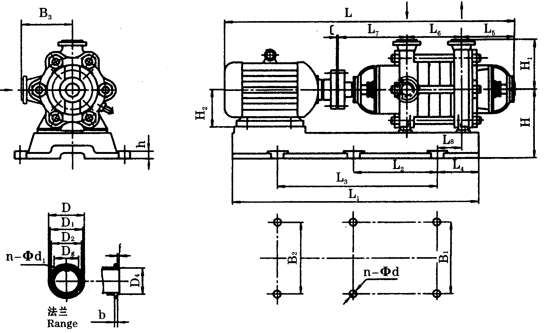

Dimensional Drawing of D-type Pump Shape Installation (Its Base)
The overall dimensions(common base)
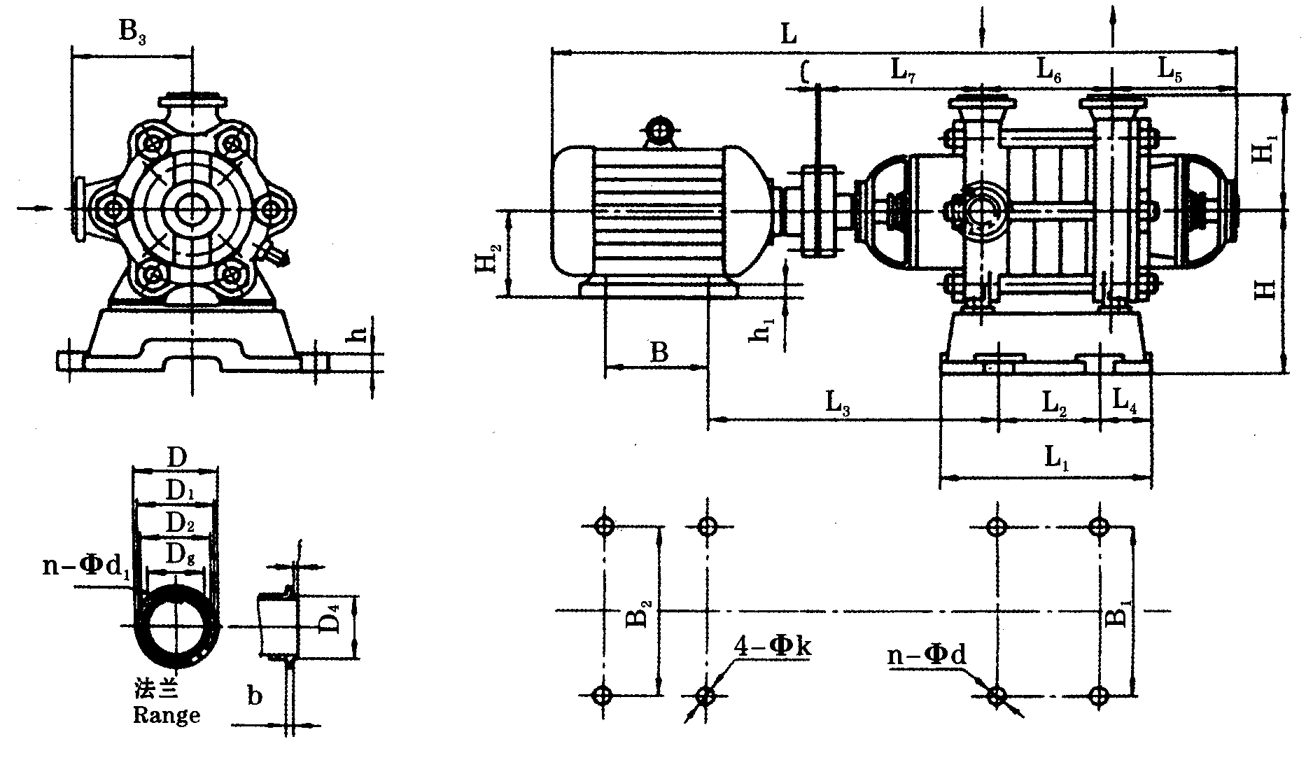

In particular:
When using this series of pumps, the shaft seal must be connected with water seal. There are two kinds of water seal used: one is the effluent of the first impeller, the other is the introduction of external water. All the water seal mentioned in Table 1 is the introduction of external water as water seal. Unmarked water intake is sealed by the effluent of the first stage impeller. The packing tightness of the shaft seal must be appropriate, when the liquid can seep out drop by drop. When the temperature of the medium being transported is higher than 80 C, cooling water must be injected into the water-cooled packing cap and shaft seal cooling chamber. The cooling water and the water seal water quoted from outside are clean water at room temperature, and the water pressure of the cooling water is 1.5-1 kg/square centimeter. The position of pipe interface of water seal and cooling water in shaft seal cooling chamber of each type of pump is different. The position of pipe interface along the axis of the interface can be seen in the pump structure diagram, and the radial position can be seen in Table 1.

Table 1--Pump Structure Diagram

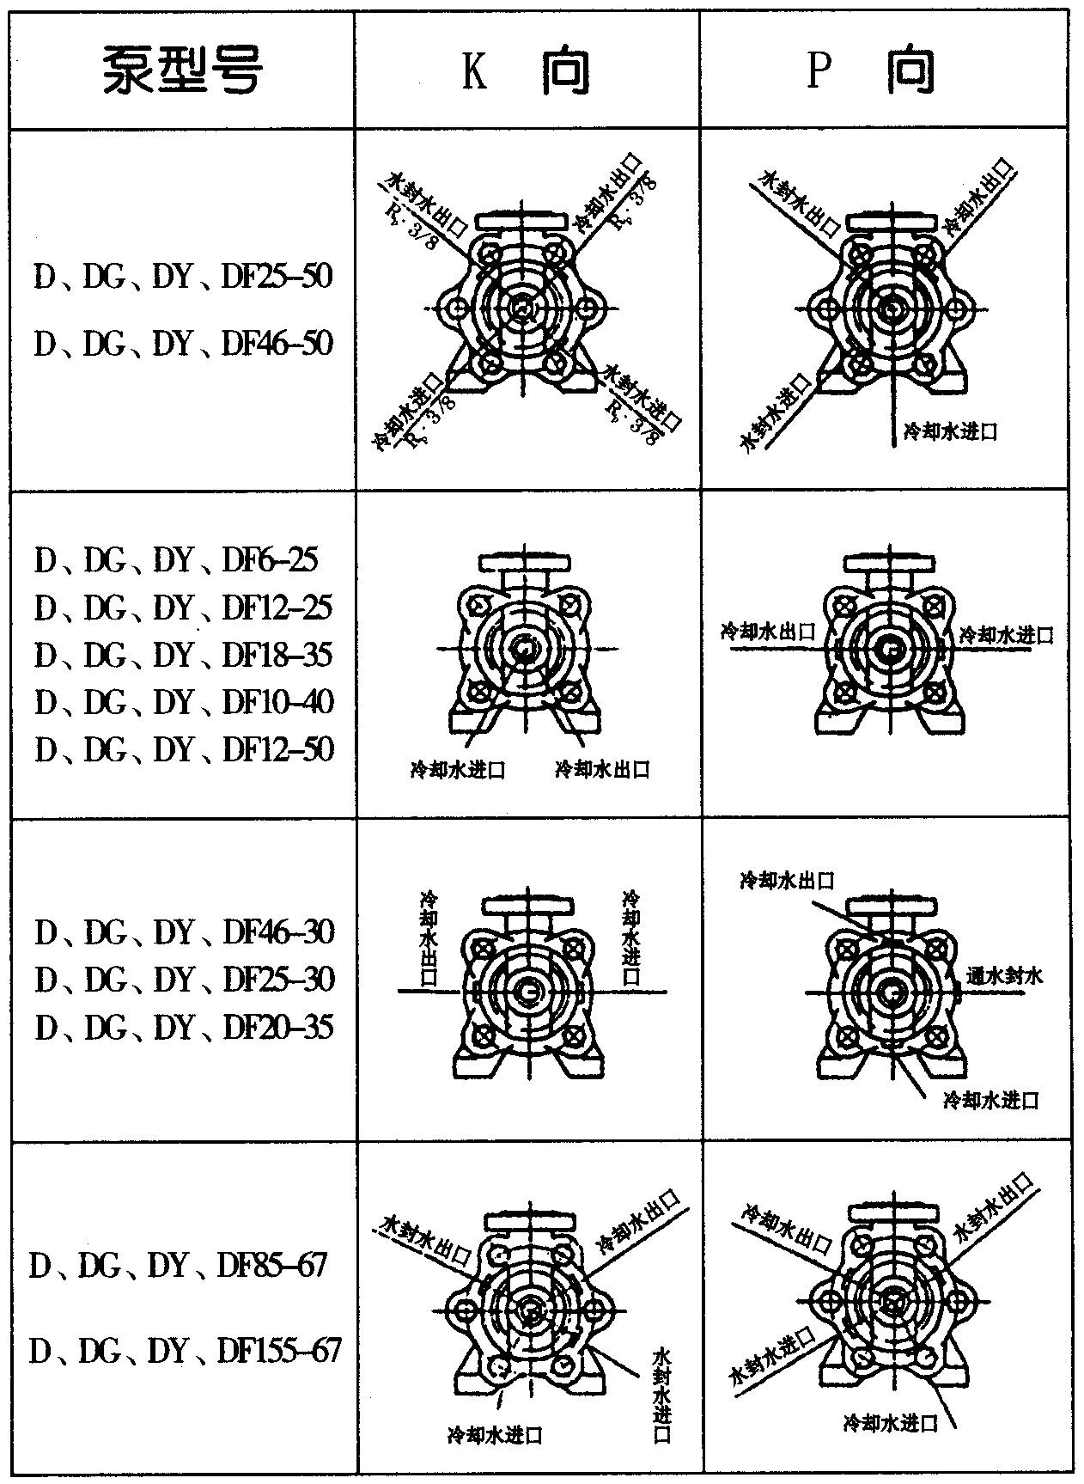

Balancing mechanism
The balance mechanism consists of balance ring, balance sleeve, balance plate and balance pipeline.
Bearing part:
Bearing part is mainly composed of bearing body and bearing. This type of pump bearing is composed of sliding bearing and rolling bearing. Bearings do not bear the axial force, the pump in operation, the rotor part in the pump body should be free to move axially, can not use centripetal ball bearings.
Sealing and Cooling of Pump
Molybdenum disulfide grease is applied to seal the joint surface of the front, middle, rear and guide vanes in the shell part. The rotor part and the fixed part are sealed by sealing rings, guide vane sleeves, packing, etc. When the wear degree of the sealing ring and guide vane sleeve has affected the work and performance of the pump, it should be replaced in time. In the use of this type of pump, the position of packing rings should be placed correctly. The distribution of packing rings of each type of pump is shown in the table.

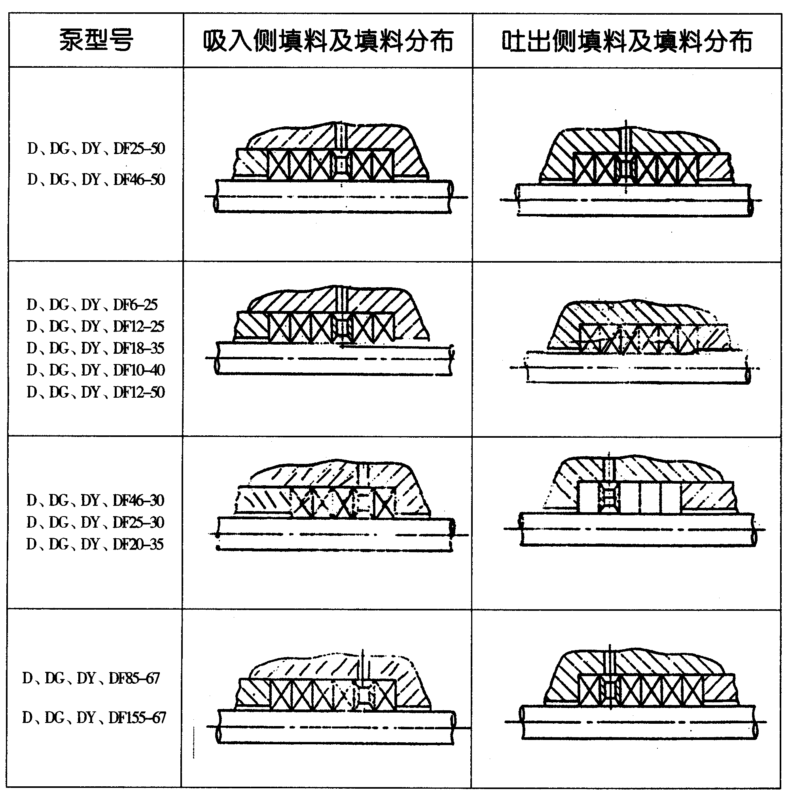

Installation and disassembly of pumps:
(1) Component assembly:
1. Clean and wipe all parts.
2. Install the sealing ring on the impeller.
3. Install the guide vane on the guide vane, and then install the guide vane on all the middle sections.
4. Install the guide vanes in the outlet section, double-headed bolts on the lime, and packing or machine sealing caps.
5. fill the parts of the water return pipe.
6. Put impeller on the shaft and install impeller files.
(2) Assembly:
1. Insert the shaft into the outlet section and install the inlet section.
2. Install the middle part of the guide vane, then install the second key, impeller and impeller files. Repeat the above steps until all the keys, impeller, impeller files and the middle part are completed.
3. Tighten the intake, middle and outlet sections together with tension bolts.
4. Install the water jacket bearing, install the bearing body on the outlet and inlet sections, and fasten the bolts.
5. Inject proper amount of butter into the bearing body and cover the paper pad on the bearing cover. Install the bearing cover on the bearing body and fasten it with bolts. Install pump coupling. Manual disc is used to move the rotor to check whether the rotor is flexible or not.
6. Install the motor on the motor base and fasten it with bolts.
7. Install the parts of the filling water supply pipe on the pump. If the fixed shaft seal is a mechanical seal, the drainage hose for mechanical seal drainage should also be installed.
8. Install coupling pin and packing. Install vent valve and all square bolts. Pump disassembly is carried out in the opposite steps described above.
(3) Matters needing attention in assembly:
The assembly quality of this type of pump directly affects the normal operation of the pump, and affects the life and performance parameters of the pump. Affect the vibration and noise of the unit. Attention should be paid to the following points in assembly:
A. The concentricity of each part of the fixed part is guaranteed by the manufacturing accuracy and assembly quality of the parts. The neutrality of the runner directly affects the performance of the pump, and it is not allowed to touch or scratch. Molybdenum disulfide used as sealant should be clean. Strong bolts and bolts should be uniformly loaded.
B. The neutrality of impeller outlet runner and guide vane inlet runner is guaranteed according to the axial dimension of each part. The neutrality of the runner directly affects the performance of the pump, so the size of the pump can not be adjusted at will.
C. After the assembly of the pump, before the packing is installed, the pump rotor is rotated by hand to check whether the housing of the rotor is flexible and whether the axial channeling momentum meets the required requirements.
D. After the above inspection meets the requirements, the filler is added to the shaft seals at both ends of the pump, and the relative position of the filler ring in the filler is noticed.

Pump Installation
1. Check the intact condition of pump and motor before installation.
2. Check pump foundation and prepare lifting tools. Pumping room should be ventilated, not allowed to sunlight and rain.
3. Place the pump on the base of the cushion 30-40 mm high, ready to fill the cement slurry.
4. Make alignment and wear the foot bolts properly. Filling cement mortar.
5. After 3-5 days of cement drying, re-align and tighten the anchor bolts.
6. Pre-test bottom valve tightness, install inlet and outlet pipelines and valves.
7. Pressure gauges should be installed at the outlet of the pump to observe and control the operation of the pump.
8. In addition to meeting the general installation technical requirements, the following points should be paid attention to when installing this type of pump.
A. When the motor and pump are assembled, the end axle of the pump coupling should be extended outward, and the axial clearance between the pump and the motor coupling should be guaranteed.
B. Pump and motor axes should be in the same horizontal straight line.
C. Pumps can only withstand their own pressure and can not withstand any pressure.

Starting, running, stopping and maintenance of pumps
1. Clean up the surrounding of the pump.
2. Add calcium-based butter into the bearing. Hand-disc rotor should be flexible without grinding phenomenon.
3. Turn on the motor and check whether the motor steering is in accordance with the pump.
4. Open the vent valve at the outlet flange and pour water into the pump or use a vacuum pump to divert water.
5. Close the gate valve and pressure gauge cock on the exhaust pipe.
6. After the above work, start the motor and open the pressure gauge cock.
7. When the pump rotates at normal speed, when the pressure is displayed on the pressure gauge, open the vacuum gauge cock and gradually open the outlet gate valve until the required pressure is reached.
8. In operation, the bearing temperature of the pump shall not exceed the external temperature of 35 C, and its limit temperature shall not exceed 75 C. Butter is injected into bearings with a high-pressure gun every 500 hours of operation.
9. The normal leakage degree in packing room or sealing room should be 30-60 drops per minute. The pressure degree of packing cover or mechanical seal cover should be adjusted at any time.
10. Check coupling regularly and pay attention to bearing temperature rise.
11. When the pump stops, the gate valve in the outlet pipeline should be closed, the vacuum gauge cock should be closed, and the motor should be stopped, then the pressure gauge cock should be closed.
12. When abnormal noise is found in the rotation of the pump, it should be stopped immediately to check its cause.
13. In the cold winter season, if the pump is shut down for a short time, the quadrangular snail race on the intake section should be unscrewed. Release the stored water to avoid freezing and cracking of the pump.
14. After long-term use of the pump, if the flow pressure has significantly decreased, the pump should be dismantled for inspection and replacement of its vulnerable parts.
15. When the pump is stopped for a long time, the pump should be disassembled, the water of the pump parts should be wiped dry, the rust scale removed, and the rust-proof grease coated, and then re-installed and properly preserved.
Possible failures and other solutions
fault | Reason | solution
1.Pump does not absorb water, pressure gauge and vacuum gauge pointer fluctuate violently. | Insufficient irrigation water. Leakage occurs at the connection between the pipeline and the instrument. | Check whether the bottom valve is leaking, and then fill the water to tighten the leak.
2. The water pump does not absorb water. The vacuum meter indicates a high vacuum. | The bottom valve has not been opened or blocked, and the resistance of the suction pipeline is too large. Water absorption is too high. | Check the bottom valve and replace the suction pipe to reduce the suction height.
3. Pressure gauge has pressure, but still does not water. | The outlet pipe has too much resistance. The direction of rotation is not right. Impeller blockage, pump speed is not fast. | Check or shrink the short water pipe and check the electricity. Clean impeller, increase pump speed.
4. Flow rate is lower than design requirement. | The pump is blocked, the seal ring is worn too much and the speed is insufficient. | Clean up the pump and pipeline, replace the sealing ring to increase the speed.
5. The pump consumes too much power. | Packing pressure is too tight, and heat, impeller wear, pump flow increased. | Tell the packing cover to check whether the pump shaft is bent, change the impeller, and increase the outlet resistance. Reduce flow.
6. The sound inside the pump is abnormal and the pump can't get water. | The resistance of the suction pipe is too large, there is air infiltration at the suction point, and the temperature of the liquid transported is too high. | Maintenance and water pipes, check bottom valves, reduce water absorption height, fill leaks, reduce temperature.
7. Vibration of pump and overheating of bearing. | Motor and pump are not centrifugal, bearing oil shortage or wear. | Adjust the motor and pump to align the center, refuel or change the bearing.

! Cautions in Use

1. The pump balances the axial force by the internal balancing mechanism. The balancing device has balanced fluid outflow. The balancing fluid has a balanced pipe connected to the suction section or a short pipe outside the balancing room. The balanced fluid flows out of the pump through the short pipe. In order to ensure the normal operation of the pump, the balancing pipe must not be blocked.
2. There is no cooling device for the hydraulic bearings of this type of pump. The assembly quality of the pump should not be higher than 35 C in the case of bearing temperature change, and the maximum temperature should not be higher than 75 C.
3. The rotor of this type of pump has certain axial movement in operation, so the clearance between the motor and the coupling surface should be guaranteed.
4. Pumps should regularly inspect impellers, sealing rings, guide vane bushes, balancing discs, bushes and wear during operation, and should be replaced in time when excessive wear occurs.
5. Fine operating procedures should be worked out according to specific conditions in use.

Complete range of supply
Supply Range of Complete set
1. Pumps
2. The prime mover can be equipped with explosion-proof motor, ordinary motor, steam turbine or diesel engine according to user's needs.
3. Base and foot bolts (as required)
4. Coupling and coupling cover
5. Pipeline system or accessories with partial cooling and sealing, not for auxiliary pumps
Instructions for Order
Ordering Instructions
1. Pump specifications, materials, cooling and sealing pipeline systems and prime movers shall be determined in accordance with operating conditions. When ordering, flow rate, head, inhalation pressure, density, temperature and medium should be provided. Flammability, explosiveness, toxicity, corrosiveness, crystallinity of medium and whether liquid seal is allowed to infiltrate into medium should be pointed out.
2. If there are special requirements for the prime mover, the user should specify the site conditions, ambient temperature and humidity, installation location and type (explosion-proof, fire-proof and other requirements) voltage size.
3. If the user needs to choose the shaft seal, the manufacturer will decide the type, specifications and materials of the supply according to the conditions of use when ordering. It can also supply according to the user's requirements.
4. The above requirements are all written on the Data Sheet.

