1. Summary of A.B.C type vertical multi-stage cylindrical bag condensation pump:

Vertical multi-stage condensate pump is a series of products developed by our company by introducing the design and manufacturing technology of Hitachi Manufacturing Institute in Japan. It is suitable for condensate pump conveying condensate water in condenser in thermal power system of large thermal power plant, including various specifications for 100, 125 (145), 200, 300, 600 and 1000MW turbogenerator units. 。 It can also be used as a device with low requirement of cavitation allowance or as a pump with high suction range for pumping other liquids whose physical and chemical properties are similar to those of clean water, and the temperature of liquids does not exceed 80 C.

Data parameters of 1.1A.B.C vertical multi-stage cylindrical bag condensation pump:
Flow range: Q 120-2400 m3/s
Head range: H 42~346m

1.2 Type description of vertical multi-stage cylindrical bag condensation pump:

B640 (I, II, III) - 5
B-initial stage double suction helical (second stage single suction) guide vane centrifugal condensation pump
640 - nominal diameter of guide vane of pump mm;
I - Pump axial seal adopts mechanical seal.
II - Pump body bears axial thrust;
III - Pump body bears axial thrust and pump axial seal adopts mechanical seal.
5-Pump Series
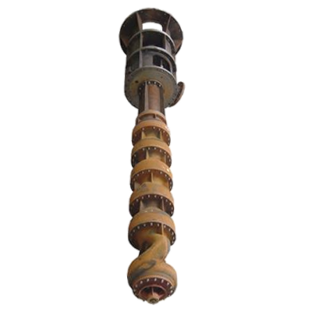
Type 1.3A.B.C Vertical Multi-stage Cylinder-bag Condensation Pump:
Vertical condensate pump is a vertical external simplified pump with three structural forms.

(1) Type A-Initial Dual-suction Guide Vane Multi-stage Centrifugal Condensation Pump
(2) B-initial stage double suction helical guide vane multi-stage centrifugal condensation pump
(3) C-initial stage double suction helical oblique flow multi-stage condensation pump

The installation form of A.B.C type vertical multi-stage cylindrical bag condensation pump unit is direct connection installation. The axial force is borne by the motor, and also by the pump body. The axial seal of the pump is packed, or mechanical seal can be used.
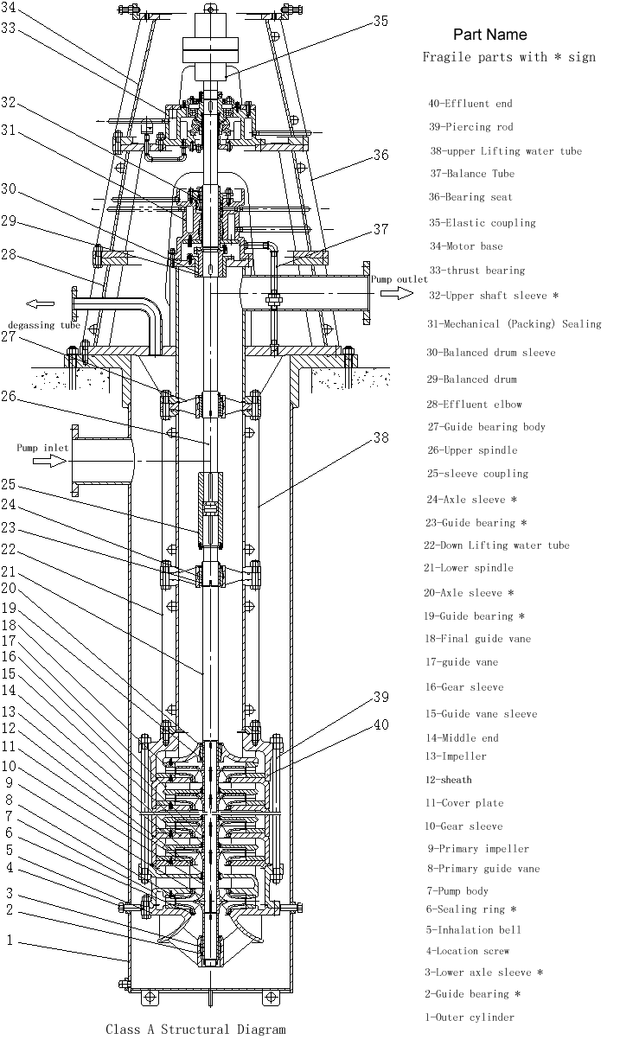

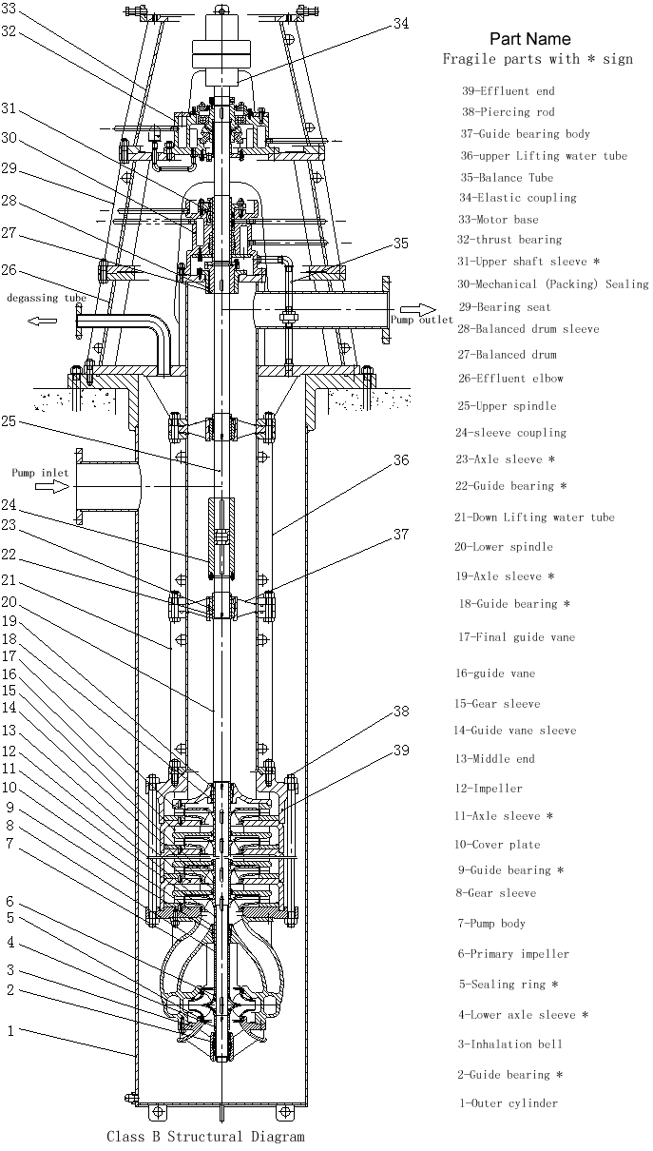
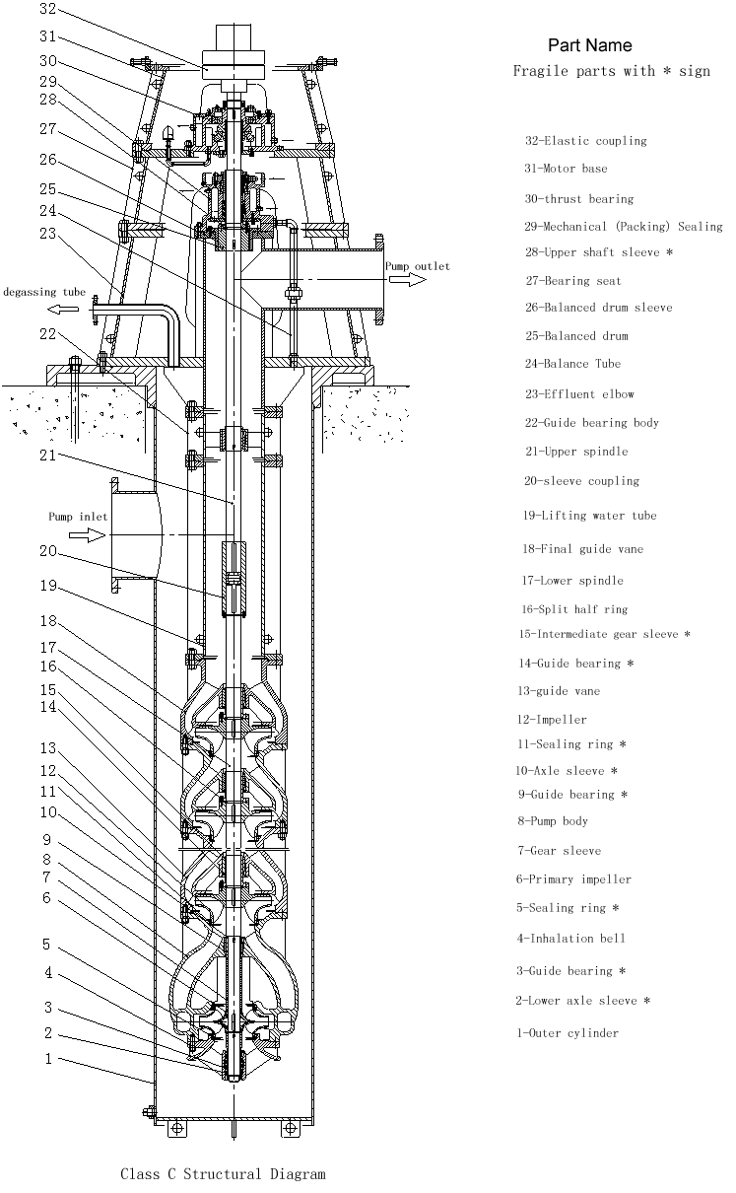
Rotation direction of 1.4A.B.C type vertical multi-stage cylindrical bag condensation pump:
Seen from the motor to the pump, the pump rotates counterclockwise

1.5A.B.C. Vertical Multi-stage Cylinder Bag Condensation Pump Material:
External simplification: Q235-A/stainless steel
Impeller: Stainless steel.
Sealing ring: ZG2Cr13.
Axis: 45 steel
Shell: QT450-10

1.6A.B.C. Vertical Multi-stage Cylinder Bag Condensation Pump Complete Range:
Complete supply pump, vertical motor.
2. Structure description of A.B.C type vertical multi-stage cylindrical bag condensation pump (see structure chart)

Integral Structure of 2.1 A.B.C Vertical Multi-stage Cylinder-bag Condensation Pump

The pump is a vertical double shell structure with a single foundation. The impeller is closed and arranged in the same direction, and the first impeller is double suction. The suction port of the pump is located under the foundation, and the outlet is on the basis. The two can be arranged at 90 degree and 180 degree angles. The inner shell can be pulled out for maintenance and repair.

The axial thrust and rotor weight of the pump are borne by the pump body, and the pump and the motor are connected by an elastic coupling.
From the motor end, the pump rotates counterclockwise.
Structure Composition of 2.2 A.B.C Vertical Multi-stage Cylinder-bag Condensation Pump

2.2.1A.B.C. External Cylinder of Vertical Multi-stage Cylinder-bag Condensation Pump

The outer cylinder body is a circular cylinder part welded by high quality carbon steel plate or stainless steel plate, on which a suction opening is arranged. The outer cylinder body is the outer pressure chamber of the pump, and the liquid can be steadily introduced into the suction bell mouth. The working chamber of the normal temperature pump is in a vacuum state, while the working chamber of the high temperature pump is in a positive pressure state.
Rotor of 2.1.2A.B.C Vertical Multi-stage Cylinder-bag Condensation Pump

The pump rotor is the core part of the pump, which is composed of impeller, pump shaft, key, bush, block and other parts. The first impeller is double suction, so as to improve the anti-cavitation performance of the pump.

Impeller: The impeller transforms the mechanical energy of the prime mover into the energy of water through high-speed rotation.
Pump shaft: The main transmission torque, through the elastic coupling and motor connection.

Pump shaft and impeller are connected by keys and semi-retaining rings. The keys transfer the torque, and the semi-retaining rings (or retaining rings) are positioned axially.

Guide Vane or Guide Vane of 2.1.3A.B.C Vertical Multi-stage Cylinder-bag Condensation Pump

The function of guide vane or guide vane is to convert the kinetic energy of liquid into pressure energy and guide the liquid flowing out of impeller to the next impeller or outlet with minimum loss. The connection between guide vane bodies is fixed by stop and bolt. The guide bearing and sealing ring are installed in the part. The guide vane is positioned in the middle section by pins.

2.1.4A.B.C Vertical Multi-stage Cylinder-bag Condensation Pump Outlet Bend and Bearing Seat

The outlet elbow is welded by straight pipe section, transverse pipe section and support plate, and the upper spindle passes through the center of this part. The liquid flowing from the last stage guide vane or the outlet section passes through this section and enters the pressure pipeline outside the pump horizontally. The outlet elbow is provided with a degassing port to discharge the gas in the outer cylinder into the condenser or outside the pump body. The bearing seat is mounted on the outlet elbow, and the motor seat is mounted on the upper part of the bearing seat.
2.1.5 Balance Drum and Balance Drum Sheath

Balancing drum plays the role of balancing the axial force, can balance most of the axial force, can greatly improve the service life of bearings. Balance drum must be matched with balance tube.

Guide Bearing of 2.1.6A.B.C Vertical Multi-stage Cylinder-bag Condensation Pump
The guide bearing acts as a radial support for the pump shaft. It is made of copper alloy, Cylon and Tianlong. The lubricant is used to transport the fluid for the pump itself.

Guide Bearing Body of 2.1.7A.B.C Vertical Multi-stage Cylinder-bag Condensation Pump
The guide bearing body is used to install the guide bearing.

2.1.8 A.B.C Vertical Multi-stage Cylindrical Bag Condensation Pump Packing Seal Components or Mechanical Seal Components

If the pump is sealed with filler, the filler is packed in the filler box, and the sealing water should be added outside. If mechanical seal is used, in order to assemble conveniently, the assembled structure is generally adopted, and external flushing water is needed. The specific requirements for sealing or flushing water are shown in the random assembly drawing.

A cooling chamber is arranged on the packing or sealing body, and external cooling water is needed when the temperature of the conveying medium is higher than 80_U+2103. The specific requirements are shown in the random assembly drawing.
2.1.9 A.B.C. Coupling Components of Vertical Multi-stage Cylinder-bag Condensation Pump

When there are two pump shafts, sleeve coupling is used between the two shafts, and elastic coupling is used between the rotor and the motor.

3. Assembly and Disassembly of A.B.C Vertical Multi-stage Cylinder Bag Condensation Pump

When the pump is discharged from the factory, random data such as assembly drawings and assembly drawings should be carefully read when disassembling or assembling.

3.1 Disassembly

3.1.1 Disassemble Pipeline

Before disassembling the pump body, the small piping should be disassembled.
(1) The small pipes to be dismantled include balancing pipes, degassing pipes, cooling chamber pipes, shaft sealing water sealing pipes or machine sealing flushing pipes, and oil pipes in thrust bearing components;
(2) When disassembling piping, marking should be made at the joint of piping to facilitate assembly.
(3) After the piping is dismantled, in order to prevent foreign bodies from entering, the piping mouth shall be sealed with plastic cloth, etc.
(4) Removal of fasteners should be properly kept in case of loss.

3.1.2 Remove the coupling pin

Remove the pins, nuts and washers in the elastic coupling components.

3.1.3 Removal of motor and motor base
(1) Confirm that the power supply is off and remove the power cable;
(2) Remove the connecting studs, nuts and washers between the motor and the motor base;
(3) Lifting the motor and moving it to the temporary storage place;
(4) A support frame should be set up in the motor storage area to ensure that the lower end of the motor coupling does not touch the ground and the motor does not tip over.
(5) Remove the motor base.

3.1.4 Dismantling Pump Coupling
(1) Pull out pump coupling;
(2) Coating anti-rust oil on shaft hole of coupling.

3.1.5 Removal of thrust bearing components
(1) Remove the locking nut after turning out the countersunk head screw in the locking nut;
(2) Remove the bearing cover and the oil seal ring installed in the inner hole of the bearing;
(3) Remove the cooling chamber cover;
(4) After releasing the lubricating oil in the inner cavity of the bearing, the oil-proof barrel is removed from below.
(5) Remove deep groove ball bearings, transmission sleeves and thrust self-aligning roller bearings;
(6) Remove the bearing body.

3.1.6 Disassemble Shaft Seal Components
(1) Remove the bearing seat;
(2) Remove the packing cap, packing and packing ring (when the shaft seal is packed);
(3) Remove the assembled mechanical seal (when the shaft seal is a mechanical seal);
(4) Remove the packing or mechanical seal;
(5) Remove the cooling chamber cover;
(6) Remove the guide bearing in the filler (seal) and the key to prevent rotation.

3.1.7 Dismantling Balance Drum, etc.
(1) Remove the upper axle sleeve;
(2) Remove the half-stop ring and balance drum;
(3) Remove the balance drum sleeve.

Removal of 3.1.8 Pump Body
(1) Remove the connecting nut of the water bend pipe and the outer cylinder;
(2) The pump body is lifted from the outer barrel body (since the positioning screw plays a positioning role under the outer barrel body, the pump body must be lifted vertically and gently when lifting the pump body);
(3) The opening part of the outer barrel body should be provided with a well cover to prevent people or foreign bodies from falling into the wellbore.

3.1.9 Pump Body Placement

The pump body is hoisted and transported to the disassembly site for horizontal disassembly.

3.1.10 Removal of outlet elbow and riser
(1) Remove the connecting bolts of the outlet water elbow and the guide bearing body and the upper water pipe, and hoist the water elbow horizontally.
(2) Horizontal lifting of the guide bearing body and the riser pipe;
(3) Remove guide bearings and anti-rotation keys installed in guide bearings;
(4) In order to prevent the bending of the pump shaft, the shaft outside the pump body needs to be supported by square wood.

3.1.11 Remove sleeve coupling components
(1) Remove the connecting bolts between the thrust clasp and the sleeve coupling body and remove the thrust clasp;
(2) Make the sleeve coupling body move outward along the upper main axis until the connecting clasp in the sleeve coupling body is completely exposed, and then remove the connecting clasp;
(3) Remove the sleeve coupling body from the upper spindle.

3.1.12 Remove the riser (if any)

Horizontally hoist the lower guide bearing body and the lower riser, and remove the guide bearing, retaining ring and anti-rotation key in the guide bearing body.
Removal of 3.1.13 Inner Shell and Rotor Components
(1) Remove the connecting nut of the threading bar and the threading bar (for type A and B pumps);
(2) Remove the connecting studs on the suction bell mouth, remove the guide bearings, retaining rings and anti-rotation keys in the suction bell mouth and its inner hole, and remove the sealing rings;
(3) Unscrew the small round nut at the end of the shaft and remove the sleeve and the first impeller (double suction type);
(4) Remove the first guide vane (for Class A pumps)
(5) For Class A and B pumps, remove the cover plate, remove impeller, guide vane, shield and middle section. For Class C pumps, the last stage guide vane body, intermediate bushing, half baffle ring and impeller are removed from the other end.
(6) For Class A and B pumps, the last guide vane and outlet section are removed; for Class C pumps, the guide vane body, intermediate shaft sleeve, split half baffle ring and impeller are removed.
(7) The parts removed above shall be placed on the flat plate without damage or loss.
Assembly of 3.2A.B.C Vertical Multi-stage Cylinder-bag Condensation Pump
The assembly sequence is contrary to the disassembly sequence, but the following points should be noted:

3.2.1 Overall
(1) O-rings and gaskets shall be assembled in accordance with the requirements of random assembly drawings to determine the location, quantity, specifications and materials of the assembly, and note that no scratches shall be found on the surface of the seals, let alone omitted during installation;
(2) Lubricants (such as molybdenum disulfide, etc.) should be applied to all moving parts, key surfaces and bolt threads.
(3) Attention should be paid to the dropping of key and other small parts.
(4) When assembling, foreign bodies should be prevented from entering the pump, especially tools and so on.
(5) The positioning screw on the sleeve shall be screwed in after the sleeve is fully installed and then riveted or spot welded.
(6) Four positioning screws on the outer cylinder body have been welded firmly on the outer cylinder body and can not be disassembled.

Confirmation of 3.2.2 Pump Foundation Level
Before the outer cylinder is hoisted into the pump pit, it is necessary to ensure that the level of the installation foundation meets the requirements.

3.2.3 Filling (for packing seal)
(1) Check whether the size of the new packing is accurate, and measure whether the corresponding size of the packing chamber is in accordance with the packing. When replacing fillers, it is important to remember that the size of fillers can not be calculated according to the old ones removed.
(2) When cutting the filler, the filler should be carefully wound around the rod (tube) with the same outer diameter as the upper sleeve. In order to ensure that the packing can be cut accurately, two parallel lines can be gently drawn on the surface of the packing, and then the packing can be cut off.

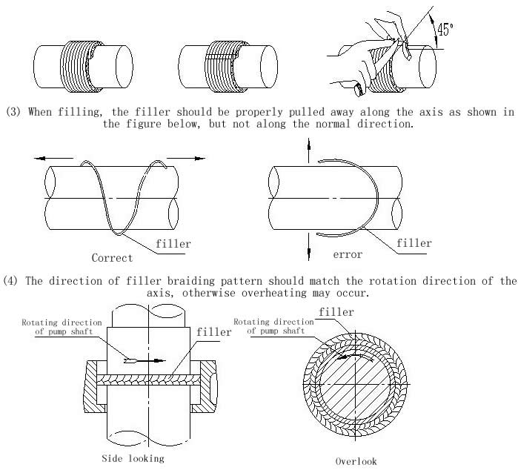

(5) After filling, screw on the nut to adjust the packing cap, so that the leakage water is in a continuous state of leakage.

Installation of 3.2.4 O-ring
(1) Installation form of O-ring: U+25CB-ring in condensation pump series belongs to fixed seal, the main sealing forms are as follows:

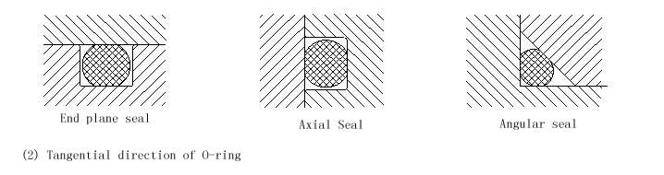

When O-ring is bonded by rubber strip, the following points should be paid attention to:
A. The cutting length of rubber strip should be measured according to the actual installation position.
B. The notch should be 45 degrees from the rubber strip axis.
C. If there are burrs on the surface of rubber strip, it should be carefully repaired.

4. Installation of A.B.C Vertical Multi-stage Bag Condensation Pump

Whether the installation quality is good or not will have a significant impact on the operation of the pump, we must be serious and careful.

Foundation of 4.1 Pump
(1) The foundation of the pump should be firm and firm;
(2) The height of the outer cylinder is adjusted by inclined pad iron between the outer cylinder body and the foundation, so that the upper plane of the outer cylinder body is on the horizontal plane, and the level is checked by the level meter. The tolerance of the level is 0.05 mm/1000 mm.
(3) After positioning the outer cylinder body, cement mortar is poured into the bolt hole of the foot from below the floor, and the bolt nut of the foot can be tightened after the cement mortar is dried and solidified.
(4) Cement mortar must completely fill the cavity under the floor.

4.2 Pipeline Connection

When connecting pipes and valves, if the tightening force of connecting bolts is too large or uneven, the additional moment will cause deformation of the pump body and bad internal contact, which directly affects the normal operation of the pump. Therefore, after the installation of valves and pipes, the unit level should be corrected again.

4.3 No foreign body remains in the pipeline

In the process of installation, foreign bodies should not fall into the pump, otherwise the pump will be easily damaged.

Installation of 4.4 Inhalation Pipeline

Inhalation pipeline should be as short as possible and the bend of pipeline should be far away from the flange of pump inlet. When connecting suction pipeline and pump inlet flange, it is necessary to ensure that the joint surface is completely sealed to prevent air from entering the pump.

Installation of 4.5 Motor
(1) Pump coupling and motor coupling are installed on the pump shaft and motor shaft respectively, and the motor is hoisted on the motor base.
(2) Check the alignment of the two couplings: Fix the dial base on the pump couplings to check the motor couplings'runout, the allowance is 0.08mm. Check the end clearance difference between the two couplings (see table below for the end clearance value), the allowance is 0.10 mm. If the above measured values are out of tolerance, the adjusting bolts in the four adjusting seats on the motor seat can be adjusted, and thin copper sheets can be padded between the motor connecting flange and the motor seat to make the jump value meet the requirements.

Coupling Outer Diameter（mm） | 170 | 190 | 220 | 260 | 330 | 410 | 640
End clearance of two coupling  （mm） | 4 | 4 | 4 | 5 | 6 | 7 | 8
(3) After the coupling is qualified for neutrality, the pin of the connecting column is installed, and then the motor is fastened with bolts or studs.

4.6 Rotor Lifting Height

The residual axial thrust of the pump is borne by the thrust aligning roller bearing in the thrust bearing component of the upper part of the pump. The lifting height of the rotor is realized by adjusting the locking nut in the part.
(1) Loosen the locking nut, so that the rotor parts slowly and freely fall until they no longer fall;
(2) Slowly tighten the locking nut so that the rotor can not rise again. Measure the total height of the rotor (generally about 10 mm);

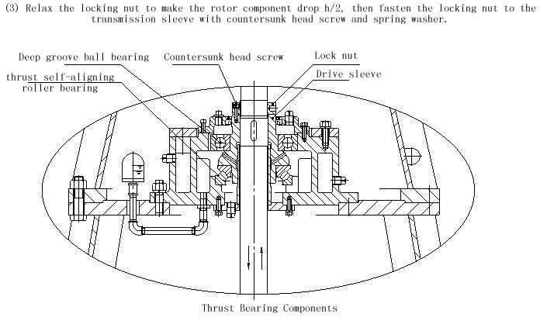
V. Starting, Operation and Stopping of A.B.C Vertical Multi-stage Bag Condensation Pump

5.1 Check preparation before starting
(1) Clean up the site and check whether the anchor bolts are loose;
(2) Whether the inlet valve of the pump is fully open;
(3) Is the pump filled with liquid?
(4) Open the exhaust valve on the condenser and exhaust the gas in the pump completely.
(5) Whether the outlet valve of the pump is closed or not;
(6) Whether the motor steering meets the requirements;
(7) Whether the pin of the coupling is loose or not;
(8) Whether the cooling water for bearings and axle seals is opened or not, and whether the filling sealing water or machine seal flushing water pipeline is unobstructed;
(9) Whether the motor and other electrical appliances and instruments are normal or not;
(10) Rotating the rotor of the pump should be able to rotate evenly and lightly without stuck or unilateral phenomenon.

Starting of 5.2 A.B.C Vertical Multi-stage Cylinder-bag Condensation Pump
(1) Close the outlet gate valve and pressure gauge cock;
(2) Starter motor;
(3) When the motor speed reaches the rated value, open the pressure gauge cock, and gradually open the outlet gate valve, adjust the outlet pressure to the required working conditions. When the outlet gate valve is closed, the continuous operation time of the pump shall not exceed 2 minutes.
(4) When the shaft seal of the pump is packed, the pressure nut on the packing cover should be tightened evenly so as to make the liquid leak continuously and pay attention to the temperature rise in the packing chamber.

Operation of 5.3 A.B.C Vertical Multi-stage Cylinder-bag Condensation Pump
(1) The temperature of rolling bearings shall not exceed the ambient temperature of 35 +2103, and the maximum temperature shall not exceed 75 +2103;
(2) During start-up and operation, attention must be paid to the observation of instrument readings, bearing temperature, filler leakage water and temperature, vibration and noise of pump group, etc. If abnormal conditions occur, they should be dealt with immediately.
(3) Check regularly whether the cooling water and sealing water (flushing water) are unblocked and no water cut-off is allowed during operation.
(4) Pay attention to motor bearing temperature;
(5) Keep the lubricating oil level of thrust bearing components in normal position, not too high or too low, otherwise oil should be put or oiled. Generally, new oil should be replaced after 8 hours of first operation.
(6) Continuous operation is not allowed at less than 30% of the designed flow rate. If continuous operation is required under this condition, bypass pipes should be installed at the outlet of the pump and surplus flow should be connected to the inlet of the pump. Continuous operation above 120% of the designed flow rate is not allowed to avoid cavitation and motor overpower.
(7) It is strictly forbidden to increase the rated speed of the pump.

Stopping of 5.4 A.B.C Vertical Multi-stage Cylinder-bag Condensation Pump
(1) Close the pressure gauge cock;
(2) Close the outlet valve gradually;
(3) Cut off the power supply;
(4) Close the valve on the cooling water and small Piping after the pump stops turning completely.
(5) If the pump is not used for a long time, it should be disassembled, cleaned, oiled and packaged for storage.

VI. Maintenance and Maintenance of A.B.C Vertical Multi-stage Cylindrical Bag Condensation Pump

6.1 Operating Diary and Management Archives

(1) Operation Diary

Record the operation of the pump truthfully, and use it as the basis for drawing up the operation plan of the pump.

Operating diary should include at least the following contents: detection time, start (stop) time, pressure gauge reading, current, voltage, frequency, speed, vibration, noise, ambient temperature, bearing temperature, seal leakage, inlet pressure (vacuum) and other data.

(2) Management of Archives

The management files should record the time of pump and auxiliary prime mover, manufacturer, main performance parameters, overhaul and so on.

Maintenance of 6.2 A.B.C Vertical Multi-stage Cylinder-bag Condensation Pump

Correct maintenance operation is of great significance to whether the pump can operate in the best condition, give full play to its role, improve the service life of the pump, and avoid accidents. Frequent and careful inspection and maintenance is one of the important means to avoid overuse and prevent dangers in the future.

(1) Daily maintenance and inspection items:

A. Close the pressure gauge cock after the pump stops.
B. Check the leakage of cooling water, sealed water supply system, piping lines and pumps (except packing leakage);
C. Check all kinds of instruments;
D. Measure the vibration value of pump group regularly, and pay attention to whether the noise is normal or not.
E. Timely adjustment of leakage of packing seal;
F. Keep the unit clean;
G. Make running records.

(2) monthly inspection items

A. Check and adjust pumps and motors to ensure their concentricity;
B. Check the condition of lubricating oil, cooling water and sealing water;
C. Measuring the vibration and noise of the pump group;
D. For long-term unused pumps (such as standby pumps), start a run-in time of not less than 5 minutes; in the case of limited conditions, manual turning is used.

(3) Annual inspection items
A. Check the wear of the rotating part;
B. Check the clearance between impeller and sealing ring;
C. Check the cavitation and erosion of impeller, guide vane, guide vane and other parts with runner property;
D. Check the wear of bearing and upper sleeve.

Maintenance of 6.3 A.B.C Vertical Multi-stage Cylindrical Bag Condensation Pump

Pumps should be disassembled and repaired when necessary (abnormal vibration or noise, excessive bearing temperature, obvious drop of flow head, etc.). For continuous operation pumps, regular maintenance should be carried out once a year.

(1) Maintenance experience should be recorded in detail for reference in the next maintenance.
(2) Prepare spare parts in advance. When purchasing spare parts, the name, material and quantity of spare parts should be clearly stated. At the same time, the pump model, name, date of leaving the factory and number of leaving the factory should be clearly stated.
(3) disassemble according to the reverse of assembly sequence. After disassembly, rust spots on the parts need to be removed and re-painted.
(4) Check the clearance between impeller and sealing ring. The replacement criteria are shown in the table below (for reference):
Nominal diameter  （mm） | ~125 | ~160 | ~200 | ~250 | ~315 | ~400 | ~500 | ~630
Maximum allowable diameter clearance  （mm） | 1.1~1.8 | 1.2~2.0 | 1.3~2.2 | 1.5~2.5 | 1.7~2.8 | 1.9~3.1 | 2.1~3.5 | 2.4~4.0
(5) Check the clearance between guide bearing and bushing. Replacement criteria are shown in the table below (for reference)：
Nominal diameter  （mm） | ~60 | ~80 | ~100 | ~120 | ~140 | ~160 | ~180
Maximum allowable diameter clearance  （mm） | 0.4~0.8 | 0.5~0.9 | 0.6~1.0 | 0.7~1.2 | 0.8~1.3 | 0.9~1.4 | 1.0~1.5
(6) Inspect the wear condition of the sleeve, and replace the sleeve when the diameter direction is worn 1-2 mm.
(7) Check the wear of impeller, guide vane and other parts;
(8) Replacement of seals (packing, U+25CB ring, rubber pad, etc.);
(9) Assemble according to assembly sequence. After assembly, the rotor of the pump should be adjusted easily and evenly.

7. Faults, Causes and Solutions of A.B.C Type Vertical Multi-stage Cylinder-bag Condensation Pump

fault | Reason | Resolvent
Insufficient flow  No water | 1. Inhalation side or outlet side or impeller with debris blockage  2. Overwear of sealing ring or damage of impeller  3. Steering discrepancy  4. Too low speed  5. Air inhalation  6. Installation head is too high  7. The pump is not filled with conveying liquid. | 1. Clean up blockages in filter, suction port, impeller, guide vane and discharge valve system.  2. Replacement of damaged parts  3. Correction steering  4. Measure voltage and frequency, check motor  5. Exhaust the gas in the inhalation pipe and check the inhalation pipe  6. Reduce system resistance and adjust operating conditions  7. Inspection of Inhalation Pipeline System
Unable to start | 1. Faults of motor or power supply system  2. Foreign bodies in rotor components  3. Bearings are stuck  4. Starting conditions are not satisfied | 1. Maintenance of motor or power supply system  2. Cleaning rotor components  3. Cleaning or replacing bearings  4. Conditions to be met for inspection
Overload | 1. Bearing damage  2. Foreign body in pump  3. Friction between impeller and seal ring  4. Over-compacted packing  5. Excessive speed  6. Pump running beyond allowable operating range under large flow rate  7. One-phase circuit break of power supply line and single-phase operation of motor | 1. Replacement of bearings  2. Removal of foreign bodies  3. Repair or replace impellers or sealing rings  4. Relax packing  5. Check voltage, frequency, motor and adjust them.  6. Close the outlet gate valve  7. Maintenance of power supply lines
Abnormal vibration and noise | 1. Cavitation of pump  2. Excessive unbalanced weight of impeller  3. Pump and motor axles are not centrifugal or axle bending  4. Foot bolt loosening  5. Bearing damage  6. Excessive wear of guide bearings and bushes  7. The influence of discharge pipeline | 1. Increase the suction level or close the outlet gate valve  2. Impeller rebalancing  3. Concentricity of correction axis, alignment axis  4. Tighten the anchor bolts  5. Replacement of bearings  6. Replacement of guide bearings and bushes  7. Check the discharge line
Bearing heating | 1. Poor assembly and excessive eccentricity of axle center  2. Bearing damage  3. Less or less oil in bearings | 1. Check the radial runout and correct it.  2. Replacement of bearings  3. Supplementary lubricants

